

70-92 Brae Street, Inverell NSW 2360
Ph: 02 6722 3777 Fax: 02 6722 5829
e: inverell-h.school@det.nsw.edu.au
w: www.inverell-h.schools.nsw.edu.au

SENIOR STUDIES COURSE HANDBOOK
2026/2027
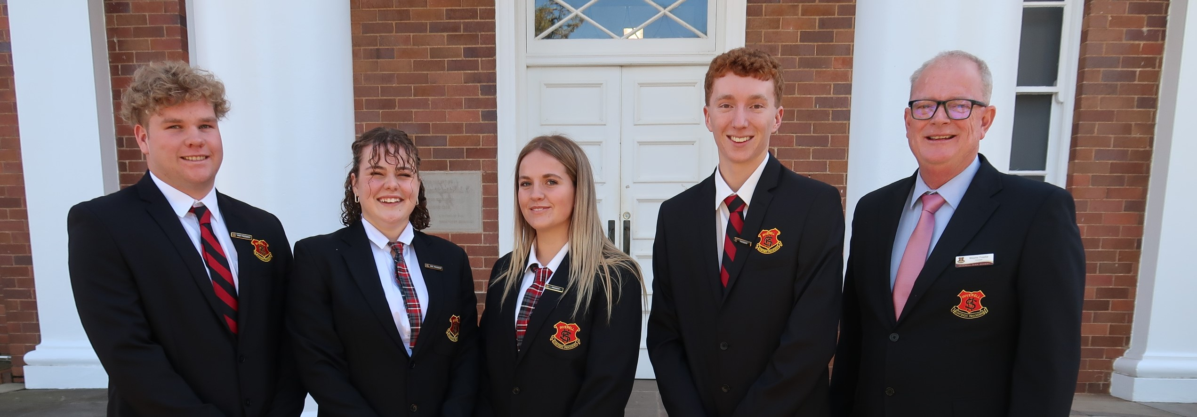

CONTENTS
STUDYING AT INVERELL HIGH SCHOOL 3
Course Patterns 3
The Higher School Certificate (HSC) 3
NSW Education Standards Authority (NESA) Courses for the HSC 3
Board Developed Courses 4
Board Endorsed Courses 4
Requirements for the award of the HSC at Inverell High School 4
Accumulation of the Higher School Certificate 4
Acceleration 5
Australian Tertiary Admission Rank – ATAR 5
Assessment and Reporting 5
Vocational Education and Training (VET) 6
School Based Part-Time Traineeships and Apprenticeships 6
Changing Subjects 6
Where to go for Help 8
Summary of Courses 9
Board Developed Courses 9
Board Endorsed Courses, School and TAFE NSW Delivered 10
Details of Courses 11
Board Developed Courses 11
Board Endorsed Courses 44
VET AND TVET COURSES 49
Life Skills HSC 54
SUBJECT SELECTION INFORMATION 56

STUDYING AT INVERELL HIGH SCHOOL

Course Patterns

Our school offers a broad variety of patterns of study to cater for all our students. The patterns you can study include:

- A HSC with an ATAR (Australian Tertiary Admission Rank). This is an academic program designed for students who wish to gain entry to a tertiary institution through the ATAR (e.g. Universities)

- A HSC without an ATAR.

- A Certificate of Attainment Year 12 without meeting Higher School Certificate requirements.

- A Life Skills HSC. This program is designed for students with special educational needs. The program of study is shaped to the particular needs of the student. This pattern is NOT eligible for an ATAR. More details on this pattern of study can be found on page 53.

The Higher School Certificate (HSC)

The Higher School Certificate recognises 13 years of schooling. In the interests of greater career choices and increased opportunities at university and TAFE NSW, it offers a full range of study areas matching individual abilities, interests and goals.

Full details of the NSW Educational Standards Authority (NESA) HSC Rules can be found in the Assessment, Certification and Examination (ACE) manual. The manual is available from the NESA website.

To be eligible to enter for the HSC you must:

- Have completed government requirements for schooling to the completion of Year 10, or equivalent, or
- Be granted provisional eligibility by the Principal.

In order to receive the HSC you must:

- Meet minimum standard of reading, writing and numeracy as set down by NESA
- Study an approved pattern of Preliminary and HSC courses
- Have a satisfactory record of attendance and application in each course
- Satisfactorily undertake the School’s Assessment program in each course
- Complete a sufficient number of Preliminary and HSC courses within five examination years.

Preliminary courses are those usually taken in Year 11 and do not have an external examination. HSC courses usually commence in Term 4 Year 11 and end with the HSC examination. You must complete the Preliminary course in a subject before undertaking the HSC course in that subject.

NSW Education Standards Authority (NESA) Courses for the HSC

Most courses offered for the Higher School Certificate have a 2 unit Preliminary and a 2 unit HSC component. Each 2 unit course requires approximately 120 hours per year, or 7 hours per fortnight, of classroom study.

Extension study is available in English, Mathematics and History in the Preliminary and/or HSC years. Extension courses are designed to build on the content of the 2 unit course and require students to develop greater competence and understanding.

There are two main types of courses:

Board Developed Courses

These are courses for which the NESA develops a syllabus, setting out the aims, objectives, outcomes, structure and content. Most Board Developed HSC courses, including the VET Framework courses, may contribute to the calculation of the ATAR.

Subjects are classified as either Category A (most subjects) or Category B (e.g. English Studies, Mathematics Standard 1, Hospitality see page10-11 for full list). Students can only count a maximum of 2 units of a Category B subject if they wish to receive an ATAR.

Life Skills courses are Board Developed courses that are specially designed to meet the needs of students within the context of an individual transition-planning process. They are not examined externally, and do not contribute to an ATAR.

Board Endorsed Courses

There are two types of Board Endorsed Courses: Content Endorsed and Locally Developed. Most of the courses available are Content Endorsed Courses that have syllabuses endorsed by the Board to cater for areas of special interest. Some courses delivered by TAFE are locally designed courses that have been approved by the Board of Studies.

All Board Endorsed Courses count towards the Higher School Certificate and are listed on the Record of School Achievement. However, Board Endorsed Courses do not count towards calculation of the ATAR, as there is no external exam and assessment is school based.

Requirements for the award of the HSC at Inverell High School

English is the only compulsory Higher School Certificate subject. To be eligible for the award of the Higher School Certificate you must satisfactorily complete at least:

- 12 units in your Preliminary pattern (Year 11 – 3 terms), and 10 units HSC pattern.

Your pattern of study must include:

- At least six units of Board Developed courses
- At least two units of a Board Developed course in English
- At least three courses of two-unit value or greater
- At least four subjects.

No more than six units of Science can be studied in the Preliminary course.

Oral, practical and project work required for specific courses and the assessment requirements for each course must be completed.

A serious attempt at the required Higher School Certificate examination must be made.

Accumulation of the Higher School Certificate

Students may accumulate a HSC over a five year period. The five-year period will commence in the first year a student attempts a HSC examination or completes a HSC VET course.

Student’s accumulating a HSC will receive a Results Notice for each calendar year of study. The cumulative record will record all Preliminary and HSC courses satisfactorily completed including repeat attempts. The mark of the final attempt on a particular course is the mark counted in the ATAR.

Acceleration

Students may undertake Preliminary or HSC courses in advance of their usual cohort. School Principals will make decisions about acceleration. Accelerated students may be able to undertake additional units for the HSC or undertake further study at TAFE NSW or university whilst still at school.

Australian Tertiary Admission Rank – ATAR

The Australian Tertiary Admission Rank (ATAR) is number between >30 and 99.95 with increments of 0.05. It provides a measure of a student’s overall academic achievement in the NSW HSC in relation to that of other students and assists institutions to rank applications for tertiary selection. It is calculated by the Universities and released by the Universities Admission Centre (UAC). The ATAR is a rank not a mark.

To be eligible for an ATAR you must satisfactorily complete at least 10 units of ATAR courses including at least 2 units of English and 8 units of Board Developed courses. The ATAR is based on an aggregate of scaled marks (average of examination and assessment marks) in ten units of ATAR courses comprising:

- The best two units of English

- The best eight units from the remaining units

ATAR courses are Board Developed Courses for which there are examinations conducted by the Education Standards Authority that yield a graded assessment.

Assessment and Reporting

The HSC is based on a standard referenced framework. Student performance is assessed and reported against standards of achievement established for each course.

School based assessment tasks constitute 50% of the HSC mark. The other 50% comes from the HSC examination. The HSC mark for 2 unit courses is reported on a scale of 0 to 100. A mark of 50 represents the minimum standard expected. There are five performance bands above 50 that correspond to different levels of achievement in knowledge, skills and understanding. Band 6 corresponds to the highest level of achievement, indicating a range of marks between 90 and 100.

On satisfactory completion of the HSC students receive a portfolio containing:

The Higher School Certificate Testamur - The certificate confirming achievement of all requirements for the award of the HSC.

The Record of School Achievement - The document listing the results of each HSC course satisfactorily completed.

Course Reports - Reports or marks the performance scale and band descriptors for each course.

AQF Certificate in VET - Certificate or Statement of Attainment for each Board Developed VET course studied showing modules successfully completed.

Vocational Education and Training (VET)

Vocational Education & Training (VET) courses teach industry specific skills that are relevant to future study and employment. These are competency based and allow you to gain both HSC qualifications and Australian Qualification Framework (AQF) accreditation. The AQF qualifications are recognised by industry and employers throughout Australia and give students advanced standing in related study at TAFE NSW. A mandatory workplace component is a compulsory part of all VET Framework courses.

There are nine VET Curriculum Framework courses that are based on Industry Training Packages. Students must study the 240 hour course and undertake the optional written examination to have the course contribute to the ATAR calculation. Students must also be assessed as workplace ready and complete the compulsory work placement hours for a VET course to fulfil course requirements.

The VET Curriculum Framework courses available are:

- Construction
- Hospitality Cookery
- Manufacturing and Engineering Introduction
- Primary Industries

Other VET courses are delivered by TAFE NSW (referred to as TVET courses). These courses have no external examination and do not contribute to the ATAR. Examples include Children’s Services, Hairdressing and Beauty Therapy.

School Based Part-Time Traineeships and Apprenticeships

The School Based Traineeship and Apprenticeship in NSW Program provides students with increased opportunities to gain experience and qualifications in a particular industry whilst still at school and to enhance future employment and training after the HSC. Part-time traineeships in schools provide students with the opportunity to include a recognised VET qualification within their Higher School Certificate and to combine this with paid work. Students successfully completing a school based part-time traineeship will receive the following qualifications:

- A nationally recognised VET qualification under the Australian Qualifications Framework
- A Certificate of Proficiency
- Credit towards the HSC

If you are interested in a School Based Apprenticeship/Traineeship you should consult the Careers Adviser.

Changing Subjects

Subject offerings in Years 11 and 12 are structured so that students are able to meet requirements for the award of a Higher School Certificate or Certificate of Attainment. Student selections are carefully checked to ensure students undertake a pattern of study which will lead to the credential they seek. Changing subjects is permissible at only certain times and through a specific process and form which guides this process. This is to ensure each student is supported to achieve their personal best. Students should not presume a change in subjects will be approved. Students will know a request to change subjects has been approved when they are notified by the Year Adviser.

Students studying extension courses need to be approved.

- The students must be undertaking the relevant base course.

The Principal will use the criteria outlined below as a guide to determine eligibility for the extension study.

The student has:

- provided a statement indicating why they are seeking the course which also provides an indication of post school intentions and how the subject change relates to the intended post school destination,
- satisfactorily completed requirements for their Year 11 courses of study (Preliminary component),
- completed all assessment tasks required to date on time during Year 11 Preliminary (i.e. no N-Award letters),
- the endorsement of teachers from Year 11 indicating the student has consistently demonstrated a high-level work ethic and is capable of managing additional study time for study purposes effectively,
- maintained an exemplary behaviour record at the school as recorded on the Sentral system,
- parental support for the change in subject,
- the recommendation of the Faculty Head Teacher and Careers Adviser for the change in subject.

Timing of change of subjects

Year 11 students must complete 12 units of study.

Preliminary students must collect a Change of Subject Form from the Careers Adviser. The form requires sign offs by the Careers Advisory, the teacher of the class the student is leaving, the teacher of the class the student wishes to move to, relevant Head Teachers, the Year Adviser, the parent and the Principal/Deputy Principal. All sections are to be competed and return to the Front Office. The student should not commence attending classes in the newly preferred subject until approval had been advised to the student by the Year Adviser. The student receives a ‘Confirmation of Study’ advice from the NSW Education Standards Authority This will need to be checked and signed by the student and is placed on the student’s file here at school.

At the commencement of the HSC component of Year 12 (Approximately Week 4 Term 4 after Parent/Teacher Night).

HSC students must collect a Change of Subject Form from the Careers Adviser. The form requires sign offs by the Careers Adviser, the teacher of the class the student is leaving, the teacher of the class the student wishes to move to, relevant Head Teachers, the Year Adviser, the parent and the Principal/ Deputy Principal. All sections are to be completed and returned to the Front Office. The student should not commence attending classes in the newly preferred subject until approval had been advised to the student by the Year Adviser. The student receives a ‘Confirmation of Study’ advice from the NSW Education Standards Authority. This will need to be checked and signed by the student and placed on the student’s file here at school.

During non-face-to-face lesson time students should be located within the Library.

Notes about Students changing schools

When a student changes schools midway through a study program (i.e. during any of Years 9-12), every effort should be made to align subjects studied at the former school with the new school. Under the regulations of the NESA, Principals have discretion to approve movement into courses not formerly studied even midway through a study program. For senior courses, NESA has advised that courses studied for less than 240 hours for 2 unit courses and 120 hours for 1 unit courses, will not be recognised on NESA documentation reflecting student achievements.

The new school will need to clarify courses undertaken by the student at their former school, the content of these courses and the student’s achievement within those courses.

Special Circumstances

Special circumstances may come about which, for example, can be documented and substantiated by medical practitioners which warrant a change of subjects at an unusual time, i.e. change from Food Technology due to developing allergy. To change their pattern of study, students need to complete a change of subject form in accordance with the procedures mentioned above (for their school year level). Medical certificates or documentation explaining the special circumstances should be attached to assist the Principal in considering the request. Students requesting such changes should not presume an outcome until a decision has been advised by the school.

Where to go for Help

- Head Teachers, course teachers for advice about the content of particular subjects,
- Careers Adviser for advice on careers, tertiary institution requirements, TAFE NSW courses and VET courses,
- Deputy Principal responsible for curriculum, regarding curriculum requirements, subject combinations and study at more than one school,
- Your parents.

The course descriptions that follow are intended as a guide to help you select your subjects. Classes can only be formed where sufficient students select the particular course. The fact that a course is listed here is not a commitment to run the course in a particular year.

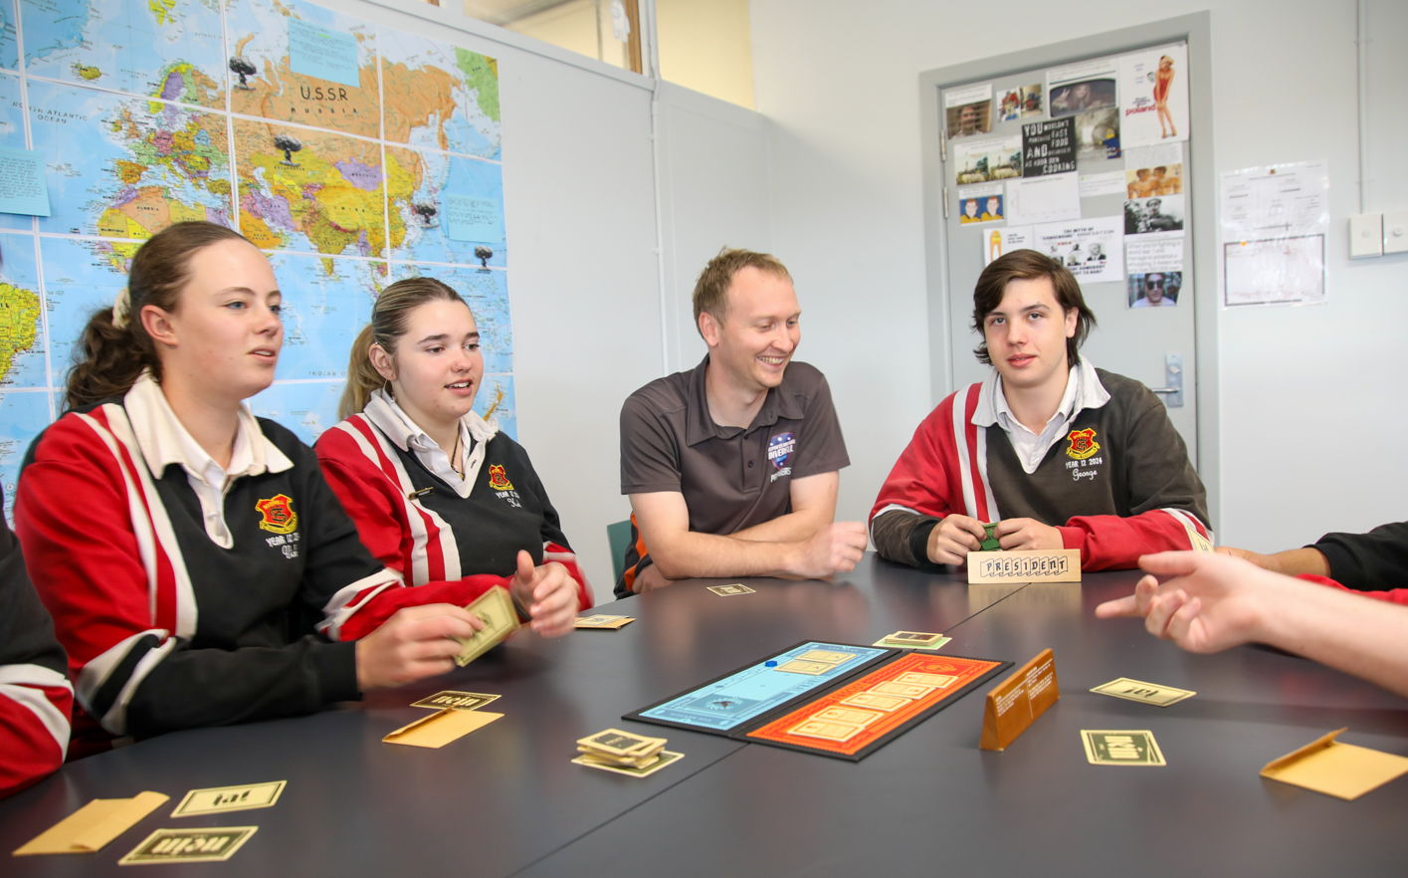

Summary of Courses offered at Inverell High School

Board Developed Courses

Course | Units | ATAR
Aboriginal Studies | 2 in Year 11 and 12 | Yes
Agriculture | 2 in Year 11 and 12 | Yes
Ancient History | 2 in Year 11 and 12 | Yes
HSC History Extension | 1 in Year 12 only | Yes
Biology | 2 in Year 11 and 12 | Yes
Business Studies | 2 in Year 11 and 12 | Yes
Chemistry | 2 in Year 11 and 12 | Yes
Community and Family Studies | 2 in Year 11 and 12 | Yes
Construction | 2 in Year 11 and 12 | Yes
Dance | 2 in Year 11 and 12 | Yes
Design and Technology | 2 in Year 11 and 12 | Yes
Drama | 2 in Year 11 and 12 | Yes
Earth & Environmental Science | 2 in Year 11 and 12 | Yes
English Advanced | 2 in Year 11 and 12 | Yes
English Standard | 2 in Year 11 and 12 | Yes
English Studies | 2 in Year 11 and 12 | Yes
Preliminary English Extension 1 | 1 in Year 11 only | Yes
HSC English Extension 1 | 1 in Year 12 only | Yes
HSC English Extension 2 | 1 in Year 12 only | Yes
Food Technology | 2 in Year 11 and 12 | Yes
Geography | 2 in Year 11 and 12 | Yes
Health & Movement Science | 2 in Year 11 and 12 | Yes
Industrial Technology | 2 in Year 11 and 12 | Yes
Investigating Science | 2 in Year 11 and 12 | Yes
Italian (Beginners) | 2 in Year 11 and 12 | Yes
Legal Studies | 2 in Year 11 and 12 | Yes
Mathematics Standard | 2 in Year 11 | Yes
Mathematics Standard 1 | 2 in Year 12 | Yes
Mathematics Standard 2 | 2 in Year 12 | Yes
Mathematics Advanced | 2 in Year 11 and 12 | Yes
Preliminary Mathematics Extension 1 | 1 in Year 11 only | Yes
HSC Mathematics Extension 1 | 1 in Year 12 only | Yes
HSC Mathematics Extension 2 | 1 in Year 12 only | Yes
Modern History | 2 in Year 11 and 12 | Yes
HSC History Extension | 1 in Year 12 only | Yes
Music 1 | 2 in Year 11 and 12 | Yes
Physics | 2 in Year 11 and 12 | Yes
Primary Industries | 2 in Year 11 and 12 | Yes
Science Extension | 1 in Year 12 | Yes
Society and Culture | 2 in Year 11 and 12 | Yes
Textiles and Design | 2 in Year 11 and 12 | Yes
Visual Arts | 2 in Year 11 and 12 | Yes

Board Endorsed Courses, School and TAFE NSW Delivered

Course | Units | ATAR
Exploring Early Childhood (School Delivery) | 2 in Year 11 &/or 12 | No
Manufacturing and Engineering Introduction (School Delivery) | 2 in Year 11 and 12 | No
Numeracy (Content Endorsed Course) | 2 in Year 11 and 12 | No
Photography (School Delivery) | 2 in Year 11 &/or 12 | No
Sports Lifestyle and Recreation (School Delivery) | 2 in Year 11 &/or 12 | No

List of TAFE Delivered Courses refer to page 47
LIFE SKILLS HSC – See page 55

Details of Courses

Board Developed Courses

These are courses for which the NSW Education Standards Authority develops a syllabus setting out the aims, objectives, outcomes, structure and content. Board Developed Courses are all delivered at school. Most Board Developed HSC courses, including VET Framework courses, may contribute to the calculation of the ATAR.

ABORIGINAL STUDIES ATAR
2 Units in each of Preliminary and HSC Board Developed Course

What will I be doing in this course?

The Preliminary course focuses on Aboriginal peoples’ relationship to the land, Aboriginal Heritage and identity and an historical examination of colonialism, racism and prejudice from pre-contact times to the 1960s. The course also includes the development of skills in culturally appropriate research and inquiry methods. It involves a mandatory local community case study.

The Preliminary course covers:

- Aboriginality and the Land
- Aboriginal Heritage and Identity
- Local community case study

The HSC course provides for in depth study of legislation, policy, judicial processes and current events from the 1960s. During the course, students will undertake consultation with the local Aboriginal community and will study national and international Indigenous communities. Students apply research and inquiry methods through the completion of an investigation into the local history of Inverell, Ashford and Tingha.

The HSC course covers:

- Core case studies in a global perspective of Social Justice and Human Rights Issues across 2 topics chosen from health, education, housing, employment, criminal justice and economic independence
- Elective study in Aboriginality and the Land or Aboriginal Heritage and Identity
- Major Project of the students choice

What should I be able to do at the end of this course?

- Understand significant issues related to Aboriginal peoples
- Investigate issues from a variety of sources including the use of information technology
- Conduct fieldwork including community consultation
- Analyse and evaluate information from a variety of perspectives
- Communicate information effectively using a variety of media
- Develop informed and responsible values and attitudes about: social justice, intercultural understanding, empathy with Aboriginal peoples’ experiences and views and ethical practices.

How will this course help me in the future?

The knowledge, skills and competencies developed in Aboriginal Studies are useful in courses studied at university and TAFE NSW, the world of work and for everyday life. They are particularly applicable to law, policing, teaching, medicine, nursing, environmental studies, travel and tourism, communications, social work and journalism.

AGRICULTURE ATAR
2 units in each of Preliminary and HSC

What will I be doing in this course?

Agriculture is designed to develop students’ knowledge and understanding about the production and marketing of both animal and plant products. Students should also develop the associated skills and responsible attitudes that are necessary to manage and market these products in a sustainable manner.

The Preliminary course incorporates the study of the interactions between the components of agricultural production, marketing and management, while giving consideration to the issues of sustainability of the farming system. This is an ‘on-farm’, environment-orientated course.

Overview
- Agricultural systems
- Agricultural history
- Social aspects surrounding agriculture

The farm case study
- The farm as a unit of production
- Farm management
- Marketing
- Farm technology
- The agricultural workplace

Plant production
- Plants and their commercial production
- Animals, climate and resource interaction Microbes, invertebrates and pests
- Technology
- Experimental design and research

Animal production
- Animals and their commercial production
- Plants, climate and resource interaction
- Microbes, invertebrates and pests
- Technology
- Experimental design and research

The Higher School Certificate course builds upon the Preliminary course. It examines the complexity and scientific principles of the components of agricultural production and places a greater emphasis on farm management to maximise productivity and environmental sustainability. The farm as a fundamental production unit provides a basis for analysing and addressing social, environmental and economic issues as they relate to sustainability, from both national and international perspectives. This is achieved through the farm product study.

Australian agriculture faces many challenges and significant and continuous change is needed to address these challenges. New computer, satellite, robotic and biological technologies are being integrated into management systems. As farmers need to respond to changing economic, social and climatic conditions, the electives focus on innovations, issues and challenges facing Australian agriculture.

- Plant/Animal production  - Soil, nutrients and water  - Factors contributing to the degradation of oil  - Sustainable resource management  - Plant production systems  - Constraints on plant production  - Managing plant production | - Animal nutrition  - Animal growth and development  - Animal reproduction and genetics  - Animal pests and diseases  - Animal ethics and welfare  - Experimental analysis and research in plant/animal

Farm product study
- The farm as a business
- Decision-making processes and management strategies
- Agricultural technology
- Marketing of a specific farm product

Elective - ONE of the following
- Agri-food, Fibre and Fuel Technologies
- Climate Challenge
- Farming for the 21st Century

What should I be able to do at the end of this course?

- Use knowledge and understanding of the physical, chemical, biological, social, historical and economic factors that interact in agricultural production systems
- Manage agricultural production systems in a socially and environmentally responsible manner
- Evaluate technology and management techniques used in sustainable agricultural production and marketing
- Understand the impact of innovation, ethics and current issues on Australian agricultural systems.

How will this course help me in the future?

The study of Agriculture provides students with knowledge, understanding and skills that form a valuable foundation for a range of courses at university and other tertiary institutions.

In addition, the study of Agriculture assists students to prepare for employment and full and active participation as citizens. In particular, there are opportunities for students to gain recognition in vocational education and training.

ANCIENT HISTORY ATAR
2 Units in each of Preliminary and HSC and an optional 1 Unit HSC Extension Board Developed Course

What will I be doing in this course?

The Preliminary course is structured to provide students with opportunities to develop and apply their understanding of methods and issues involved in the investigation of the ancient past. Through the use of archaeological and written sources, students investigate various aspects of the ancient world, including historical sites, people, societies, events and developments.

The course has three main components of study:

- Investigating Ancient History – this module examines the nature of Ancient History and focuses on two case studies – one from Egypt, Greece, Rome or Celtic Europe and the other from the Near East, Asia, The Americas or Australia.
- Features of Ancient Societies – this module will examine a key feature in two different ancient societies. Features may include: women; slavery; art & architecture; weapons & warfare; death & funerary customers; power & image or trade & culture contact.
- Historical Investigation – this module allows students to pursue their own area of interest in Ancient History and refine their investigative, research and presentation skills.

The Ancient History course for the HSC is divided into four modules, each of equal weight:

- The Core Section: The Cities of Vesuvius – Pompeii and Herculaneum. This module combines a study of archaeological remains with written documentation and looks at the lifestyles of people in the ancient towns prior to the eruption of Mt Vesuvius in 79AD. It looks at how this disaster both destroyed and preserved the sites and also examines the processes of archaeology over time. Other ethical issues such as the display of human remains, conservation and ownership are also explored.

- Ancient Society: Students will study the ancient Greek city state of Sparta. They will look at the lifestyles of people and the myths and legends associated with the site. Students will examine archaeological and written sources and try to establish their values and limitations.

- The Historical Period: Students will study Rome during the period of the Fall of the Roman Republic 78-31 BC. Students will look at the structure and development the Roman Republic, and the factors which ultimately lead to its demise. This module will evaluate both archaeological and written evidence and concentrate on the notion of continuity and change.

- The Personality in their Time: Students develop an understanding of Julius Caesar in the context of his time, through a range of archaeological and written sources and relevant historiographical issues. Students will examine his life, the role he played in the fall of the Roman Republic and legacy left in not just Rome, but the world.

How will this course help me in the future?

Skills developed in the study of Ancient History are useful in a range of courses studied at university and TAFE NSW as well as in the workforce and everyday life. They are particularly applicable to law, teaching, medicine, travel and tourism, librarianship, communications, social work and journalism. A high level of achievement in Ancient History is a good indicator of success at tertiary level in a wide range of courses.

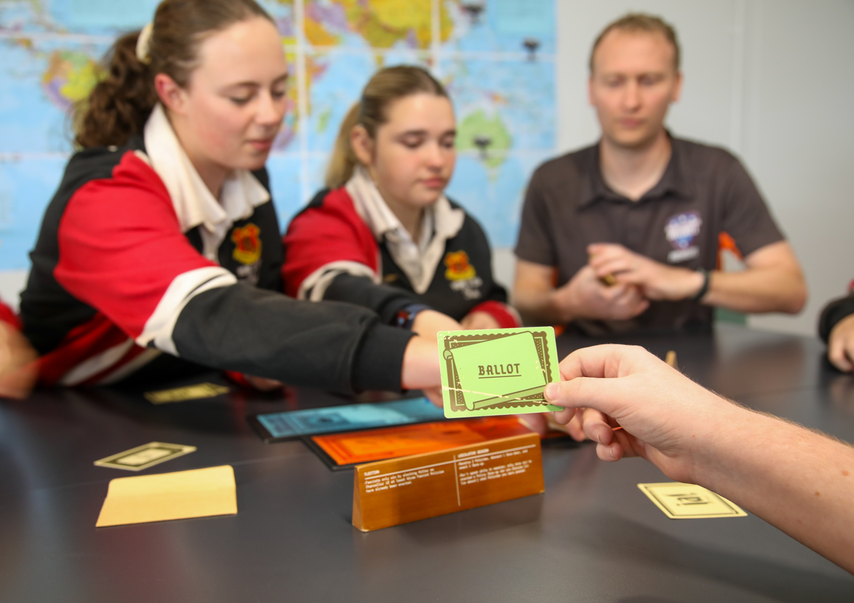

EXTENSION HISTORY ATAR

The HSC History Extension Course involves the study and evaluation of the ideas and processes used by historians to produce history. In Part 1 of the course, students investigate the question, ‘What is history?’ through readings compiled in a source book and through one case study. In Part II, students design, undertake and communicate a personal historical inquiry.

Students must have successfully completed the Preliminary Course and be currently studying a HSC Course in either Modern or Ancient History to attempt the Extension and must have good research skills and an independent approach to learning to be successful.

What should I be able to do at the end of this course?

- Collect, analyse and organise information
- Communicate ideas and information clearly in both written and oral forms
- Plan and organise activities
- Work with others as part of a team
- Use appropriate information technologies
- Understand the influence of the ancient past on the present and the future
- Understand, value and respect different viewpoints, ways of living, beliefs and languages.

How will this course help me in the future?

Skills developed in the study of Extension History are useful in a range of courses studied at university and TAFE NSW as well as in the workforce and everyday life. They are particularly applicable to law, teaching, medicine, travel and tourism, librarianship, communications, social work and journalism. A high level of achievement in Ancient History is a good indicator of success at tertiary level in a wide range of courses.

HSC History Extension will provide you with critical and reflective thinking skills that are essential for effective participation in work, higher learning and the broader community. In particular, the course will develop many higher order skills and methodologies that are of great value to students intending to undertake tertiary studies and are transferable between disciplines.

BIOLOGY ATAR
2 Units in each of Preliminary and HSC Board Developed Course

What will I be doing in this course?

The Biology Stage 6 Syllabus explores the diversity of life from a molecular to a biological systems level. The course examines the interactions between living things and the environments in which they live. It explores the application of biology and its significance in finding solutions to health and sustainability issues in a changing world.

Biology uses Working Scientifically processes to develop scientific investigative skills. It focuses on developing problem-solving and critical thinking skills in order to understand and support the natural environment. When Working Scientifically, students are provided with opportunities to design and conduct biological investigations both individually and collaboratively.

Practical investigations are an essential part of the course and must occupy a minimum of 35 hours of course time in each year, including time allocated to practical investigations in depth studies.

The Preliminary course Modules are:

- Cells as the Basis of Life
- Organisation of Living Things
- Biological Diversity
- Ecosystem Dynamics

Working Scientifically skills are integrated through the whole course. 15 hours of the 120 will be dedicated to depth studies related to one or more of the modules.

The HSC course Module topics are:
- Heredity
- Genetic Change
- Infectious Disease
- Non-infectious Disease and Disorders

Working Scientifically skills are integrated through the whole course. 15 hours of the 120 will be dedicated to depth studies related to one or more of the modules.

How will this course help me in the future?

The course provides the foundation knowledge and skills required to study biology after completing school and supports participation in a range of careers in biology and related interdisciplinary industries. It is a fundamental discipline that focuses on personal and public health and sustainability issues and promotes an appreciation for the diversity of life on the Earth and its habitats.

BUSINESS STUDIES ATAR
2 Units in each of Preliminary and HSC Board Developed Course

What will I be doing in this course?

Business Studies investigates the role, operation and management of businesses within our society. Factors in the establishment, operation and management of a small business are integral to this course. Students investigate the role of global business and its impact on Australian business. Students develop research and independent learning skills in addition to analytical and problem-solving competencies through their research projects, which investigate the operation of a small business or planning the establishment of a small business.

In the Preliminary course student’s study:

- Nature of Business – the nature and role of business
- Business management – nature and responsibilities of management in the business environment
- Business Planning – processes of establishing and planning a small to medium enterprise

The HSC course covers:

- Operations – strategies for effective operations management in large businesses
- Marketing – elements involved in the development and implementation of successful marketing strategies
- Finance – the role of interpreting financial information in the planning and management of a business
- Human Resources – the contribution of human resource management to business performance

What should I be able to do at the end of the course?

- Understand the nature, role and structure of business
- Appreciate the functions, processes and operations of business
- Understand the role of effective business management
- Investigate, analyse and evaluate business issues
- Communicate business information using appropriate formats
- Apply mathematical concepts appropriate to business situations
- Develop values and attitudes about ethical business behaviour and the social responsibility of business.

How will this course help me in the future?

The study of Business Studies provides students with knowledge, understanding and skills that form a valuable foundation for a range of courses at university and TAFE NSW as well as in the workforce and everyday life. There are opportunities for students to gain credit transfer in certificate and diploma courses at TAFE NSW. Business Studies helps to prepare students for employment and full and active participation as citizens.

CHEMISTRY ATAR
2 Units in each of Preliminary and HSC Board Developed Course

What will I be doing in this course?

The Chemistry Stage 6 Syllabus explores the structure, composition and reactions of and between all elements, compounds and mixtures that exist in the Universe. The discovery and synthesis of new compounds, the monitoring of elements and compounds in the environment, and an understanding of industrial processes and their applications to life processes are central to human progress and our ability to develop future industries and sustainability.

The course further develops an understanding of chemistry through the application of Working Scientifically skills. It focuses on the exploration of models, understanding of theories and laws, and examination of the interconnectedness between seemingly dissimilar phenomena.

Practical investigations are an essential part of the course and must occupy a minimum of 35 hours of course time in each year, including time allocated to practical investigations in depth studies.

The Preliminary course Modules are:

- Properties and Structure of Matter
- Introduction to Quantitative Chemistry
- Reactive Chemistry
- Drivers of Reactions

Working Scientifically skills are integrated through the whole course. 15 hours of the 120 will be dedicated to depth studies related to one or more of the modules.

The HSC course Module topics are:

- Equilibrium and Acid Reactions
- Acid/base Reactions
- Organic Chemistry
- Applying Chemical Ideas

Working Scientifically skills are integrated through the whole course. 15 hours of the 120 will be dedicated to depth studies related to one or more of the modules.

How will this course help me in the future?

The course provides the foundation knowledge and skills required to study Chemistry after completing school and supports participation in a range of careers in chemistry and related interdisciplinary industries. It is an essential discipline that currently addresses and will continue to address our energy needs and uses, the development of new materials, and sustainability issues as they arise.

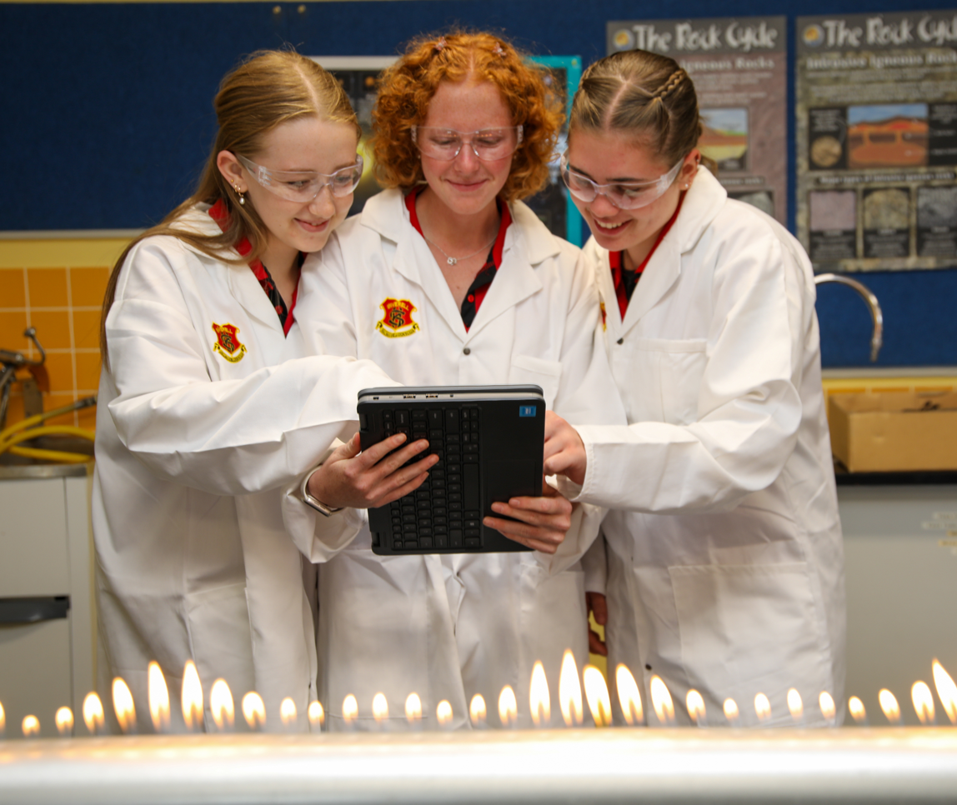

COMMUNITY AND FAMILY STUDIES ATAR
2 Units for each of Preliminary and HSC Board Developed Course

What will I be doing in this course?

Community and Family Studies is designed to develop in each student an understanding of the diverse nature and interdependence of families and communities, within Australian society. The course enables students to plan and manage resources effectively in order to address contemporary issues facing families and communities.

The Preliminary course covers:

- Resource Management – Basic concepts of the resource management process.
- Individuals and Groups – The individual’s roles, relationships and tasks within groups.
- Families and Communities – Family structures and functions and the interaction between family and community.

The HSC course covers:

Research Methodology culminating in the production of an Independent Research Project; Groups in Context – The characteristics and needs of specific community groups; Parenting and Caring – issues facing individuals and groups who adopt roles of parenting and caring in contemporary society and one of the following HSC option modules: Family and Societal Interactions, Social Impact of Technology and Individuals and Work.

Students are required to complete an Independent Research Project as part of the HSC internal assessment. The focus of the Independent Research Project should be related to the course content of one or more of the following areas: individuals, groups, families, communities, resource management.

What should I be able to do at the end of this course?

- Manage resources and take action to support the needs of individuals, groups and families in Australian society
- Understand the influence of a range of societal factors on individuals and the nature of groups, families and communities
- Demonstrate research skills
- Demonstrate skills in critical thinking and the ability to take responsible action to promote well being
- Appreciate the diversity and inter- dependence of individuals, groups, families and communities.

How will this course help me in the future?

This course develops skills and understanding that is relevant to life after school. It helps students to set goals and make decisions about themselves, their families and the community. It is relevant to a wide range of further study at both TAFE and university and has particular application in careers such as Business Management, Human Resource Management, Teaching, Social Work, Nursing, Counselling and Marketing.

CONSTRUCTION 240 hours ATAR
2 units in each of Preliminary and/or HSC Board Developed Course
Vocational Education and Training (VET) Course

The Construction curriculum framework includes courses that are accredited for the HSC and provide students with the opportunity to obtain nationally recognised vocational qualifications.

Students who are assessed as competent in all of the prescribed units of competency in Construction (240 hours) will be eligible for a Statement of Attainment showing partial completion of CPC20120 Certificate II in Construction (Release 3). Students may be eligible for CPC20220 Certificate II in Construction Pathways (Release 6).

What will I be doing in this course?

This course is for students who wish to work in the construction industry. The course is based on units of competency developed by the construction industry to describe the competencies and skills and knowledge needed by workers in this industry. The course incorporates ten core units plus a range of elective units from the General Construction area. The core units of competency represent the basic skills, knowledge and attitudes required by all workers within the construction industry. Students will need to develop and exhibit these competencies throughout the entire course. These core units of competency focus on developing and refining the skills required to work effectively within the industry. The core units of competency specifically address industry awareness, communicating with others, planning for work, quality principles, working safely and introductory tools and techniques.

The electives available in the course complement these competencies by providing a range of practical and technical skills.

What else do I need to know about this course?

- Students must complete a minimum of 35 hours work placement each year in a construction workplace.
- This is a competency-based course. This means that students work to develop the competencies, skills and knowledge described in each unit of competency. To be assessed as competent a student must demonstrate to a qualified assessor that they can effectively carry out the various tasks and combinations of tasks listed to the standard required in the industry. There is no mark awarded in competency-based assessment. Students are assessed as either ‘competent’ or ’not yet competent’. Competency based assessment determines the vocational qualification that a student will receive. There is an optional Higher School Certificate examination for Construction (240 hours). The written examination consists of multiple choice items, short answers and extended response items. The questions will be based on units of competency and HSC Requirements and Advice detailed in the syllabus. The examination is independent of the competency-based assessment undertaken during the course and has no impact on the eligibility of a student to receive a vocational qualification.
- A materials fee applies to this course.

What should I be able to do at the end of this course?

- Be familiar with the construction industry and career structures within the industry.
- Seek and attain suitable and rewarding employment in the construction industry.
- Function competently and confidently at the entry level standard of a construction work environment.

How will this course help me in the future?

The competencies, skills and work experience students gain in this course equip them well for direct entry into the work force, particularly into trades such as carpentry and general construction. There are direct articulation arrangements with TAFE NSW and students are able to complete a TAFE NSW diploma in minimum time and articulate, if they choose, to university, with advanced standing. FEES APPLY

See back of booklet for competency list and further information. Construction curriculum framework has an optional examination. The result of this examination can be used to calculate a student’s performance relative to their peers in determining an ATAR.

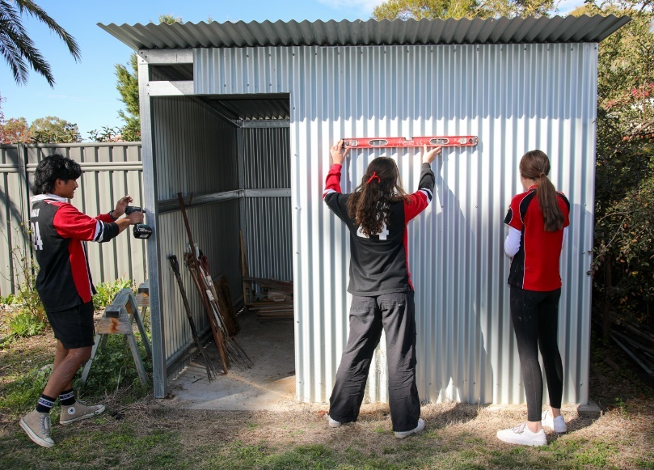
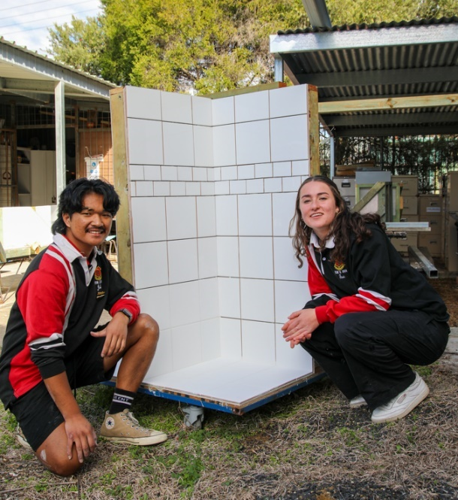

DANCE ATAR

2 Units in each of Preliminary and HSC Board Developed Course

What will I be doing in this course?

In Stage 6 Dance, students journey into the world of movement and expression. Throughout the course, students dive into the art of dance, exploring performance, composition, and the appreciation of this vibrant form of expression. Within Dance, students gain insights into themselves and the world around them, making it a truly enriching experience.

Throughout the Preliminary course, students explore dance as a unique art form where the body becomes an instrument for non-verbal communication and expression.
Students will:
• Master dance technique to elevate their performances to new heights.
• Hone creative abilities through the art of composition, crafting original dances.
• Develop interview skills, articulating safe dance and artistic vision with confidence.
• Dive into analysis and writing, uncovering deeper meanings behind dance.

In the HSC course, students take their Preliminary skills to an advanced level, putting them into practice to work towards the final goal of:
• Core Performance: A solo performance (3-5mins), 6-minute interview, and logbook.
• Core Composition: A solo composition (3-5mins), 6-minute interview, and logbook.
• Core Appreciation: Writing 2 dance essays in a 1-hour, 5-minute examination.
• Major Study: A choice of a 4-6min study, in addition to a 9-12min interview, and logbook.

The core content of the Preliminary and HSC Dance courses consists of a broad study of dance as an art-form organised around the three interrelated components of Performance, Composition and Appreciation.

How will this course help me in the future?

The Dance course equips students with life skills while also providing continuity with many tertiary and industry courses. Students who study the Stage 6 Dance course acquire skills and knowledge that give them access to professional employment in dance, the performing arts and the entertainment and leisure industries.

DESIGN & TECHNOLOGY ATAR
2 Units in each of Preliminary and HSC Board Developed Course

What will I be doing in this course?

Students study design processes, design theory and factors in relation to design projects.

In the Preliminary course students study designing and producing, including the study of design theory, design processes, creativity, collaborative design, research, management, using resources, communication, manufacturing and production, computer-based technologies, safety, evaluation, environmental issues, analysis, marketing and manipulation of materials, tools and techniques. It includes the completion of at least two design projects.

The HSC course includes studies in innovation and emerging technologies, including a case study. The study of designing and producing culminates in the development and realisation of a Major Design Project. The project folio includes the major project proposal and management, project development and realisation and project evaluation.

What should I be able to do at the end of the course?

- Understand design theory and processes.
- Understand and appreciate the interrelationship between design, society and the environment.
- Understand innovation and entrepreneurial activity in a range of contexts.
- Apply skills in the application of design processes to design, produce and evaluate quality design projects that satisfy identified needs and opportunities.
- Demonstrate knowledge and understanding about current and emerging technologies in a variety of settings.

How will this course help me in the future?

Design and Technology provides pathways to employment and further education. It may lead to careers in a range of design fields including industrial design, graphic design, architecture, advertising, marketing and business management. Design and Technology gives advanced standing in a number of certificate and diploma courses at TAFE NSW. FEES APPLY



DRAMA ATAR
2 Units in each of Preliminary and HSC Board developed Course

Exclusions: Projects developed for assessment in one subject are not to be used either in full or in part for assessment in any other subject.

What will I be doing in this course?

Students study the practices of Making, Performing and Critically Studying in Drama. Students engage with these components through collaborative and individual experiences.

The Preliminary course covers:

- Improvisation, Play building, Acting
- Elements of Production in Performance
- Theatrical Traditions and Performance Styles

The HSC Course involves theoretical study through practical workshops exploring theme, issues, styles and movement.

- Australian Drama and Theatre
- Studies in Drama and Theatre
- The Group Performance (3-6 students) involves creating a piece of original theatre (8 to 12 minutes duration). It provides opportunity for each student to demonstrate his or her performance skills.
- The Individual Project where students demonstrate their expertise in a particular area. They choose one project from Critical Analysis or Design (costume design; set design; promotion and program; lighting design) or Performance or Script-writing or Video Drama.

What will I be able to do at the end of the course?

- Make and perform different styles of drama
- Critically study drama and theatre
- Work both independently and with others in teams to plan and organise activities
- Solve problems
- Collect, analyse and organise information and communicate ideas and information.

How will this course help me in the future?

Students who wish to pursue a career in theatre or the entertainment industry, or in public relations and media communications can gain experience and confidence through this course. FEES APPLY

EARTH AND ENVIRONMENTAL SCIENCE ATAR
2 Units in each of Preliminary and HSC Board Developed Course

What will I be doing in this course?

The Earth and Environmental Science Stage 6 course begins in Year 11 with a focus on understanding geological and physical processes that occur in and on Planet Earth – from a study of basic geology to the theory of plate tectonics, resource extraction and human impacts on these processes. Year 12 Earth and Environmental Science explores the applications of students’ new understandings of our finite earth and apply this knowledge to propose solutions to the many challenges posed by tectonic hazards, climate change and resource exploitation.

Practical investigations are an essential part of the course and must occupy a minimum of 35 hours of course time in each year, including time allocated to practical investigations in depth studies. Opportunities for field studies and excursions also exist in Earth and Environmental Science and are usually organised on a student need or contextual basis.

The Preliminary course Modules are:

- Earth’s Resources
- Plate Tectnonics
- Energy Transformations
- Human Impacts

‘Working Scientifically’ skills are integrated throughout the whole course. 15 hours of the 120 will be dedicated to depth studies related to one or more of the modules.

The HSC course Modules are:

- Earth’s Processes
- Hazards
- Climate Science
- Resource Management

‘Working Scientifically’ skills are integrated throughout the whole course. 15 hours of the 120 will be dedicated to depth studies related to one or more of the modules.

How will this course help me in the future?

The course provides the foundation knowledge and skills required to study earth and environmental science after completing school and supports participation in careers in a range of related industries. The application of earth and environmental science is essential in addressing current and future environmental issues and challenges. It is also necessary for the use and management of geological resources that are important to Australia’s sustainable future.

ENGLISH ADVANCED ATAR
2 Units in each of Preliminary and HSC Board Developed Course

What will I be doing in this course?

Students examine the ways that events, experiences, ideas, values and processes are represented in and through texts and analyse the ways texts reflect different values and attitudes. They analyse and evaluate texts and the ways they are valued in their contexts.

The Preliminary course has two sections: content common to Standard and Advanced through a unit of work called ‘Reading to Write’ and electives. It requires:

- Study of Australian and other texts
- Exploration of a range of types of text drawn from prose fiction, drama, poetry, nonfiction, film or media or multimedia texts
- A wide reading program involving texts and textual forms composed in and for a wide variety of contexts
- Integrating the modes of reading, writing, listening, speaking and viewing and representing as appropriate
- Engaging in the integrated study of language and text.

The HSC course has two sections: common content to both Standard and Advanced courses called Texts and Human Experiences and Modules which emphasise particular aspects of shaping meaning and representation, questions of textual integrity, and ways in which text are valued.

It requires:

- The close study of at least four prescribed texts, drawn from the following categories: Shakespearean drama; prose fiction, drama or film; poetry; non-fiction or media or multimedia texts
- A wide range of additional related texts and textual forms

What will I be able to do at the end of this course?

- Effectively communicate at different levels of complexity
- Comprehend and understand the effects and purposes of a range of textual forms
- Undertake independent research, individual and collaborative learning
- Write coherently in a variety of forms.

How will this course help me in the future?

Communication is the most basic requirement in modern Australian society in any field of further study, employment or life. This is why English is the only subject that it is compulsory to study for the HSC. Students who study the Advanced English course will be well equipped for further study of English and related disciplines at university. Success in this demanding course will be a good indicator of success in a large range of courses at TAFE NSW or university.

ENGLISH STANDARD ATAR
2 Units in each of Preliminary and HSC Board Developed Course

What will I be doing in this course?

Students explore the ways events, experiences, ideas and processes are represented in and through texts. They reflect on and demonstrate the effectiveness of text for different audiences and purposes.

The Preliminary Course has two sections: content common to the Standard and Advanced courses, and Electives.

It requires:

- Study of Australian and other texts
- Exploration of a range of types of text drawn from prose fiction, drama, poetry, non-fiction, film or media or multimedia texts
- A wide reading program involving texts and textual forms composed in and for a wide variety of contexts
- Integrating the modes of reading, writing, listening, speaking, viewing and representing as appropriate
- Engaging in the integrated study of language and text.

The HSC course has two sections: content common to the Standard and Advanced courses, and Modules which provide elective choices.

It requires:

- The close study of at least three types of prescribed text, drawn from the following categories: prose fiction; drama; poetry; non- fiction or film or media or multimedia
- A wide range of additional related texts and textual forms

What should I be able to do at the end of this course?

- Understand aspects of meaning from social, cultural, workplace and personal perspectives
- Have skills in composition and response to a wide variety of texts
- Effectively communicate for a range of purposes and audiences to enhance my personal, social and vocational life.

How will this course help me in the future?

Communication is the most basic requirement in modern Australian society in any field of further study, employment or life. Therefore, English is the only subject that it is compulsory to study for the HSC. Students who study the Standard English course gain good preparation for further education at University, TAFE NSW and employment in a wide range of career areas

ENGLISH STUDIES NON ATAR at Inverell High School
2 Units each in each of Preliminary and HSC Board Developed Course

Students of Inverell High School will not be offered an HSC Examination in English Studies.

What will I be doing in this course?

Students explore the ideas, values, language forms, features and structures of texts in a range of contexts. They respond to and compose texts to extend experience and understanding, access information and assess its reliability, and synthesise the knowledge gained from a range of sources for a variety of purposes.

Preliminary Course (120 indicative hours):

- The module ‘Achieving through English – English and the worlds of education, careers and community’ is mandatory in the Preliminary course.
- Students will study a total of 3-5 modules (including the mandatory module), 20-40 indicative hours per module.

HSC Course (120 indicative hours):

- The module ‘Narrative and Human Experiences and Writing for Purpose’ are mandatory in the HSC English Studies courses.
- Students will study a total of 3-5 different modules (including the mandatory module), 20-40 indicative hours per module.

In each of the Preliminary and HSC courses students are required to complete learning activities such as:

- read, view, listen to and compose a wide range of texts, including print texts and multi-modal texts
- undertake study of at least one substantial print text and at least one substantial multi-modal text
- be involved in planning, research and presentation activities as part of one individual and/or one collaborative project
- engage with the community through avenues such as visits, surveys, interviews, work experience, listening to guest speakers and/ or excursions
- develop a portfolio of texts they have planned, drafted, edited and presented in written, graphic and electronic forms across all the modules undertaken during the year.

What should I be able to do at the end of this course?

- Understand various forms of texts by exploring the ideas and values of those texts and how language and other techniques are used in the texts to convey meaning.
- Have skills in reading, listening and viewing and in writing, speaking and representing. And demonstrate this by using language accurately, effectively and appropriately for a range of purposes, audiences and contexts.
- Students will develop skills in planning and working individually and collaboratively.

How will this course help me in the future?

Communication is the most basic requirement in modern Australian society in any field of further study, employment or life. Therefore, English is the only subject that is compulsory to study for the HSC. Students who study the English Studies course gain skills for further education at TAFE NSW and employment in a wide range of career areas.

ENGLISH PRELIMINARY EXTENSION ATAR
1 Unit in Preliminary

Texts, Culture and Value

Students examine a key text from the past and its manifestations in other contexts and media. Through close study they:

- consider the relationships between the text and its culture
- explore the language of the text and examine the ways in which language shapes and reflects values
- consider the effects of different ways of responding to the text
- consider the ways and reasons the original and later manifestations of the text or aspects of the text are valued.

Students also explore, analyse and critically evaluate different examples of such texts in a range of contexts and media, including texts of their choosing. This will include completion of an independent investigation and a multimodal presentation of their research and analysis.

ENGLISH HSC EXTENSION 1 ATAR
1 Unit in HSC

Common Module - Literary Worlds

In the common module students explore, investigate, experiment with and evaluate the ways texts represent and illuminate the complexity of individual and collective lives in literary worlds. Students evaluate how ideas and ways thinking are shaped by personal, social, historical and cultural contexts.

In their study of Worlds of Upheaval students experiment with critical and creative compositions that explore how language features and forms express complex ideas and emotions, motivations, attitudes, experiences and values in times of great change. Students are required to engage in wide reading and select their own related texts to support their study of this elective.

ENGLISH HSC EXTENSION 2 ATAR
1 Unit in HSC Board Developed Courses

Prerequisites:

- English Advanced course
- Preliminary English Extension Course is prerequisite for HSC Extension Course 1
- HSC Extension Course 1 is core requisite for HSC Extension Course 2
- Author and Authority
- Major Work

HSC Major Work Description

Students create a sustained composition, independently planned, researched and completed. There are a wide variety of text types that students may choose from to create their Major Work. These range from short stories, poetry and film to critical responses. There is no exam for this subject. Your Major Work will be due mid-August.

Students must study English Advanced and English Extension 1 English to be eligible for this course.

FOOD TECHNOLOGY ATAR
2 Units in each of Preliminary and HSC Board Developed Course

What will I be doing in this course?

Students will develop knowledge and understanding about the production, processing and consumption of food, the nature of food and human nutrition and an appreciation of the importance of food to health and its impact on society. Skills will be developed in researching, analysing and communicating food issues, food preparation and the design, implementation and evaluation of solutions to food situations.

It is mandatory that students undertake practical activities in this course.

The Preliminary course covers:

- Food Availability and Selection
- Food Quality
- Nutrition

The HSC course covers:

- The Australian Food Industry
- Food Manufacture
- Food Product Development
- Contemporary Nutrition Issues

What should I be able to do at the end of the course?

- Make responsible decisions regarding food choices
- Research and analyse information
- Experiment with, communicate, evaluate and manage resources.

How will this course help me in the future?

This course will provide you with the knowledge, skills and attitudes to contribute positively to your own pathways to employment or further education at TAFE NSW or university. The study of Food Technology will give you credit transfer in some certificate and diploma courses at TAFE NSW. Career options might include dietetics, food technology, teaching and nutrition. FEES APPLY

GEOGRAPHY ATAR
2 Units in each of Preliminary and HSC Board Developed Course

What will I be doing in this course?

The Preliminary course is an extension of the Stage 5 mandatory Geography course and provides students with opportunities to extend and investigate the world and challenges we are currently facing.

Key concepts incorporated across all topics are change, environment, sustainability, spatial and ecological dimensions, interaction, technology, management and cultural integrations.
The Preliminary course structure comprises 4 focus areas:
- Earth’s Natural Systems
- People, Patterns and Processes
- Human-Environment Interactions
- Geographical Investigation.

Including: -
- Geographical inquiry skills and tools
- Fieldwork (12 hours mandatory)
- Applying geography in the contemporary world

The HSC course structure comprises of 3 focus areas:

- Global Sustainability
- Rural and Urban Places
- Ecosystems and Global Biodiversity

Including:

- Geographical inquiry skills and tools
- Fieldwork (12 hours mandatory)
- Applying geography in the contemporary world

What should I be able to do at the end of this course?

- Understand the interactions between factors that make up the natural environment and the role of people in environmental change.
- Have the skills to observe surroundings and be able to develop strategies for effective researching.
- Gather new knowledge about the environment and the people who depend on it.
- Communicate knowledge through a wide variety of methods.

How will this course help me in the future?

Geography gives students a broad range of skills to interpret the world around them. It also helps to shape their lives so that they maximize their enjoyment of the wonders of nature while minimising the negative impact on the systems that support life on the planet.

All careers, including law, tourism and business will benefit from the study of Geography. The 21st Century is a crucial time in which people must learn to work within their planet’s ability to support them. The managers of the future must think globally and act locally. Geography gives them a head start.

HEALTH AND MOVEMENT SCIENCE ATAR
2 Units in each of Preliminary and HSC Board Developed Course

What will I be doing in this course?

The Preliminary course examines a range of areas that underpin health and physical activity. This includes current thinking about health and physical activity, strategies to promote personal health and the scientific foundation of body movement.

The Preliminary course comprises 4 mandatory components. There are two focus areas:

- Health for Individuals and Communities
- The Mind and Body in Motion
- a Collaborative Investigation
- a minimum of two depth studies.

The Collaborative Investigation provides opportunities for students to develop knowledge and skills to support their own and others’ health and movement. It allows students to manage their own learning and to become flexible, critical thinkers, problem-solvers and decision-makers.

In the HSC course, the focus is on major issues related to Australia’s health status. Students also look at the factors that affect physical performance.

The HSC course covers 3 mandatory components:

- Health in an Australian and global context
- Training for improved performance.
- and a minimum of two depth studies.

What should I be able to do at the end of the course?

- Understand individual and community health issues
- Understand basic anatomy and physiology and how it affects movement
- Have skills in analysis and in identifying strategies to promote the development of personal and community health
- Ability to critically analyse issues that impact on health and performance.

How will this course help me in the future?

Undertaking this course will provide foundation studies for those students with a special or vocational interest in human movement, and individual and community health issues.

The course would be of great benefit to anyone wishing to take up a career in any of the sport sciences, nursing, coaching or PDHPE teaching, occupational health and physiotherapy.

INDUSTRIAL TECHNOLOGY ATAR
(Automotive, Metal and Engineering)
2 Units in each of Preliminary and HSC Board Developed Course

Only ONE Industrial Technology course can be studied

What will I be doing in this course?

Industrial Technology Stage 6 consists of project work and an Industry Study, which develops a broad range of skills and knowledge, related to the industry focus area chosen and an introduction to industrial processes and practices.

The Focus Areas include: Automotive Industries; Engineering Industries. Note - only one can be studied.

In the Preliminary course, students must design, develop and construct a number of projects (at least one group project). Each project must include a management folio. Also, students must undertake the study of an individual business within the industry.

The following sections are taught in relation to the relevant focus area:

- Industry Study – structural, technical, environmental and sociological factors, personnel issues, Occupational Health and Safety
- Design and Management – designing, drawing, computer applications, project management
- Workplace Communication – literacy, calculations, graphics
- Industry Specific Content and Production.

In the HSC course, students must design, develop and construct a Major Project with a management folio. Also, they must undertake a study of the overall industry related to the specific focus area.
The following sections are taught in relation to the relevant focus area:

- Industry Study
- Design and Management
- Workplace Communication
- Industry Specific Content and Production.

What else do I need to know about this course?

The marks for this course are eligible for inclusion in the ATAR.

How will this course help me in the future?

Industrial Technology gives students knowledge and skills in a particular industry and increases job opportunities in a range of practical occupations. FEES APPLY

INVESTIGATING SCIENCE ATAR
2 Units in each of Preliminary and HSC Board Developed Course

The study of Investigating Science enables students to develop an appreciation and understanding of science as a body of knowledge and a set of valuable processes that provide humans with an ability to understand themselves and the world in which they live. The course aims to enhance students’ analytical and problem-solving skills, in order to make evidence-based decisions and engage with and positively participate in an ever-changing, interconnected technological world.

The Investigating Science course is designed to assist students of all abilities engage with scientific processes, and apply those processes to investigate relevant personal, community and global scientific issues. It is designed to enhance students’ understanding of the value of evidence-based investigations and the use of science-based inquiry in their lives.

The Investigating Science course is designed to complement the study of the other science disciplines by providing additional opportunities for students to investigate and develop an understanding of scientific concepts, their current and future uses, and their impacts on science and society. The course draws on and promotes interdisciplinary science, by allowing students to investigate a wide range of relevant STEM issues and concepts in depth.

The Preliminary HSC course modules are:
- Cause and Effect - Observing
- Cause and Effect - Inferences and Generalisations
- Scientific Models
- Theories and Laws

The HSC course modules are:
- Scientific Investigations
- Technologies
- Fact or Fallacy?
- Science and Society

Practical investigations are an essential component of the course and must occupy a minimum of 35 hours of course time in each year of study. 30 hours of the allocated course time is dedicated to primary and secondary investigations through depth studies, which may include practical components.

How will this course help me in the future?

Investigating Science encourages the development of a range of capabilities and capacities that enhance a student’s ability to participate in all aspects of the scientific community and within a fast-changing technological landscape. The knowledge, understanding and skills gained from this course are intended to support students’ ongoing engagement with science, and to form the foundation for further studies and participation in current and emerging STEM-related post-school activities and industries.

ITALIAN BEGINNERS ATAR
2 Units in each of Preliminary and HSC Board Developed Course

Exclusions: The Italian Beginners Stage 6 course is a two-year course, which has been designed for students who wish to begin their study of Italian at secondary senior level. It is intended to cater for students with no prior knowledge or experience of the language, either spoken or written. Those who have lived and/or been educated in an Italian speaking environment or who are native speakers are ineligible. Other eligibility rules apply. Students must complete a NSW Education Standards Authority statuary declaration in order to establish eligibility.

What will I be doing in this course?

In the Preliminary course students will be introduced to the Italian language and culture. They will learn grammatical structures, vocabulary and idiom within the context of topic areas prescribed in the Syllabus.

In the HSC course students will extend and refine their communication skills in Italian in contexts defined by topics and will gain a deeper knowledge and understanding of language and culture.

The topics are:

- Family life, home and neighbourhood
- People, places and communities
- Education and work
- Friends, recreation and pastimes
- Holidays, travel and tourism
- Future plans and aspirations

Students’ language skills are developed through such tasks as:

- Exchanging everyday information, experiences and opinions in conversation in the target language
- Responding to simple target language spoken at near normal speed
- Processing written target language texts
- Writing dialogues and letters using everyday conversational patterns.

What will I be able to do by the end of this course?

By the end of Year 12 a student should have developed increased competence in communicating in Italian. Taking into account the number of contact hours available, realistic objectives for the students are:

- To understand oral communication by a native speaker
- To express ideas orally on topics within her/ his experience
- To read with comprehension and enjoyment both known and new material
- To write letters, free compositions, dialogues etc.
- To gain an appreciation and increased understanding of foreign cultures

At Inverell High School we have consistently achieved results above the state average in Italian Beginners. Students have used the knowledge and skills they have acquired to continue their studies at university, travelling extensively including academic exchanges and in their chosen careers.

What else do I need to know about this course?

Studying a language offers an insight into other peoples’ culture, develops tolerance and understanding and helps increase students’ literacy skills not only in the chosen language but in English a swell. An understanding of how language works is invaluable for all learning areas as an aid to writing essays and constructing articulate thought. Students use technology such as the Internet, CD-ROMs, DVD and video conferencing to acquire the foreign language as well as more traditional classroom methods.

Students will have the opportunity to engage in authentic language and cultural experiences through excursions to exhibits and restaurants, the viewing of films and contact with native speakers and exposure to contemporary media, as part of their course work.

How will this course help me in the future?

Learning a language has direct benefits in the following areas:
- International business
- International agencies
- International law
- The tourism and hospitality industries
- The diplomatic service
- Research institutes
- As a language teacher
- A linguist
- As a translator or interpreter
- Journalism
- Navy, Army or Air Force

Second-language learners have access to a vast network of international cultural resources in areas such as fashion, design, science, architecture, literature, theatre, cinema, fine arts, music, opera and dance. FEES APPLY

LEGAL STUDIES ATAR
2 Units for each of Preliminary and HSC Board Developed Course

What will I be doing in this course?

The Preliminary course develops students’ knowledge and understanding of the nature and functions of law and law making, the development of Australian and International legal systems, the Australian Constitution and the role of the individual. This is achieved by investigating, analysing and synthesising legal information and investigating legal issues from a variety of perspectives.

The Preliminary course covers: The Legal System; The Individual and the Law; The Law in Practice.

The HSC course investigates the key areas of law, justice and human rights through a variety of focus studies that consider how changes in societies influence law reform.

The HSC course covers: Crime, Human Rights and two options of Family and World Order.

Key themes incorporated across all topics are: Justice, Law & Society, Culture, Values and Ethics, Conflict and Cooperation, Continuity and Change, Legal Processes and Institutions, Effectiveness of the Legal System.

What should I be able to do at the end of the course?

- Use and understand terms used in the legal process
- Recognise legal problems and demonstrate logical reasoning in applying legal principles
- Develop a working knowledge of the Australian legal system
- Understand the evolution of the current legal system
- Evaluate the effectiveness of our legal system.

How will this course help me in the future?

The course is not designed to prepare you for further study in the law but rather prepare you to participate effectively in everyday life. The course is designed to foster intellectual, social and moral development by empowering students to think critically about the role of the law and legal institutions in society. As a consequence of this, legal studies will provide students with an understanding of the legal system, its principles, structures, institutions and processes. It is useful preparation for further study at TAFE NSW or university in a range of areas.

MATHEMATICS ADVANCED ATAR
2 Units in Each of Preliminary and HSC Board Developed Course

Prerequisites: The Mathematics Advanced Year 11 course has been developed on the assumption that students have achieved the Stage 5 Path (Advanced) outcomes (i.e., Grade A or B in the Year 10 Advanced Pathway).

What will I be doing in this course?

The Mathematics Advanced course is designed to encourage students to appreciate mathematical ways of viewing the world to investigate concepts, such as order, relation, pattern, uncertainty and generality. The course provides students with the opportunity to explore mathematical problems through observation, reflection and reasoning and enables students to use mathematical models.

The organisation of outcomes and content for Mathematics Advanced highlights the important role Working Mathematically plays across all areas of mathematics and reflects the strengthened connections between concepts. Working Mathematically has been embedded in the outcomes and content of the syllabus.

The Mathematics Advanced outcomes and their related content are organised into 7 areas of study:
- Functions – Working with Functions, Graph Transformations, Further Graph Transformations and Modelling
- Trigonometric Functions – Trigonometry and Measure of Angles, Trigonometric Identities and Equations
- Sequence and Series – Sequences and Series
- Calculus – Introduction to Differentiation, Differential Calculus, Integral Calculus, Applications of Calculus
- Exponential and Logarithmic Functions – Exponential and Logarithmic Functions
- Statistical Analysis – Probability and Data, Random Variables
- Financial Mathematics – Financial Mathematics

What should I be able to do at the end of the course?

The study of Mathematics Advanced in Stage 6 can benefit students by helping them to:
- make connections in mathematics, across other subjects and in real-world contexts
- enhance their ability to problem-solve in familiar and unfamiliar situations
- extend their skills to communicate using the language of mathematics
- nurture their ability to think logically, critically and creatively
- prepare for a wide range of educational and employment opportunities, including the study of STEM-related fields at a tertiary level.

How will this course help me in the future?

The knowledge and skills developed in the Mathematics Advanced course can be applied across a range of career pathways and is suited for students wishing to pursue careers requiring degrees including Science, Technology, Engineering or Mathematics.

Mathematics Advanced, Mathematics Extension 1 and Mathematics Extension 2 form a continuum to provide students with opportunities to acquire knowledge, understanding and skills in mathematical concepts at progressively higher levels and with applications in an increasing number of contexts. Mathematics Advanced, Mathematics Extension 1 and Mathematics Extension 2 provide students with opportunities to learn about the interconnected nature of mathematics, its beauty and its functionality. The concepts and techniques of differential and integral calculus are the basis of the courses.

MATHEMATICS STANDARD ATAR
2 Units in Preliminary Board Developed Course

Prerequisites: The Mathematics Standard Year 11 course has been developed on the assumption that students have achieved the Stage 5 Path (Standard) outcomes.

What will I be doing in this course?

The Mathematics Standard course is focused on enabling students to use mathematics effectively, efficiently and critically to make informed decisions in their daily lives. It provides students with opportunities to develop an understanding of, and competence in, aspects of mathematics through real-world applications.

Mathematics Standard is designed for students who want to extend their mathematical skills beyond Stage 5, gain further knowledge of mathematical concepts and apply these skills and knowledge in practical contexts.

The organisation of outcomes and content for Mathematics Standard highlights the important role Working Mathematically plays across all areas of mathematics and reflects the strengthened connections between concepts. Working Mathematically has been embedded in the outcomes and content of the syllabus.

Mathematics Standard outcomes and their related content are organised into 5 areas of study:
- Algebra – Formulas and Equations, Linear Relationships
- Financial Mathematics – Earning Money, Managing Money
- Measurement – Applications of Measurement, Time and Location
- Networks – Networks, Paths and Trees
- Statistics – Data Analysis

The Mathematics Standard Year 11 course is a common course for all students studying the Mathematics Standard syllabus. In Year 12 students can elect to study either Mathematics Standard 1 or Mathematics Standard 2.

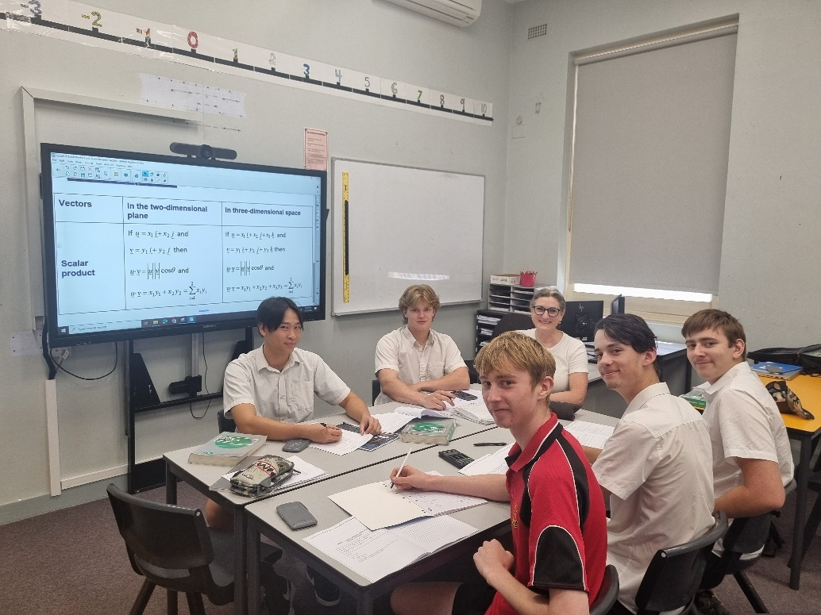

MATHEMATICS STANDARD 2 ATAR
2 Units in HSC Board Developed Course

Prerequisites: Mathematics Standard Year 11 course.

What will I be doing in this course?

Mathematics Standard 2 provides a pathway for students to extend their mathematical thinking through examining more complex content, and through applications and modelling. This course offers students the opportunity to prepare for a wide range of educational and employment aspirations.

The organisation of outcomes and content for Mathematics Standard 2 highlights the important role Working Mathematically plays across all areas of mathematics and reflects the strengthened connections between concepts. Working Mathematically has been embedded in the outcomes and content of the syllabus.

Mathematics Standard 2 outcomes and their related content are organised into 5 areas of study:
- Algebra – Algebraic Relationships
- Financial Mathematics – Investments and Loans, Annuities
- Measurement – Trigonometry, Ratios and Rates
- Networks – Network Flow, Critical Path Analysis
- Statistics – Bivariate Data Analysis, Relative Frequency and Probability, The Normal Distribution

What should I be able to do at the end of the course?

The study of Mathematics Standard 2 can benefit students by helping them to:
- use mathematics effectively, efficiently and critically to make informed decisions in their daily life
- develop an understanding of and competence in aspects of mathematics through real-world applications
- prepare for a wide range of educational and employment aspirations, including continuing their studies at a tertiary level.

How will this course help me in the future?

The knowledge and skills developed in the Mathematics Standard 2 course can be applied across a range of career pathways and is suited for students wishing to undertake degrees requiring two units of Mathematics.

Industries related to this course include, but are not limited to:
- Electricity, Gas, Water and Waste Services
- Financial and Insurance Services
- Information Media and Telecommunications
- Professional, Scientific and Technical Services
- Rental, Hiring and Real Estate Services

MATHEMATICS STANDARD 1 ATAR (Category B)
2 Units in HSC Board Developed Course

Prerequisites: Mathematics Standard Preliminary course.

What will I be doing in this course?

Mathematics Standard 1 provides an opportunity for students to continue to master aspects of the Year 11 outcomes and develop their mathematical knowledge and understanding through applications and modelling. This supports students to see the significance of mathematics and have the opportunity to prepare for post-school employment or further training.

The organisation of outcomes and content for Mathematics Standard 1 highlights the important role Working Mathematically plays across all areas of mathematics and reflects the strengthened connections between concepts. Working Mathematically has been embedded in the outcomes and content of the syllabus.

Mathematics Standard 1 outcomes and their related content are organised into 5 areas of study:
- Algebra – Algebraic Relationships
- Financial Mathematics – Investment, Depreciation and Loans
- Measurement – Right-angled Triangles, Ratios and Rates
- Networks – Networks, Paths and Trees
- Statistics – Bivariate Data Analysis, Relative Frequency and Probability

What should I be able to do at the end of the course?

The study of Mathematics Standard 1 can benefit students by helping them to:
- use mathematics effectively, efficiently and critically to make informed decisions in their daily life
- develop an understanding of and competence in aspects of mathematics through real-world applications
- prepare for a wide range of educational and employment aspirations, including continuing their studies at a tertiary level.

How will this course help me in the future?

The knowledge and skills developed in this course can be applied across a range of career pathways.
Industries related to this course include, but are not limited to:
- Electricity, Gas, Water and Waste Services
- Financial and Insurance Services
- Information Media and Telecommunications
- Professional, Scientific and Technical Services
- Rental, Hiring and Real Estate Services

Students studying the Mathematics Standard 1 course may elect to opt out of the HSC examination if they do not wish for the course to contribute to an ATAR.

MATHEMATICS EXTENSION 1 ATAR
1 Unit in both Preliminary and HSC Board Developed Course

Prerequisites: Students must also be undertaking the Mathematics Advanced course.

What will I be doing in this course?

Mathematics Extension 1 enables students to develop a thorough knowledge and understanding of and competence in further aspects of mathematics as an extension of the Mathematics Advanced course. The course provides opportunities to develop rigorous mathematical arguments and proofs, and to use mathematical models more extensively.

The organisation of outcomes and content for Mathematics Extension 1 highlights the important role Working Mathematically plays across all areas of mathematics and reflects the strengthened connections between concepts. Working Mathematically has been embedded in the outcomes and content of the syllabus.

Mathematics Extension 1 outcomes and their related content are organised into 7 areas of study:
- Functions – Further Work with Functions, Polynomials
- Proof – Proof by Mathematical Induction
- Vectors – Introduction to Vectors
- Trigonometric Functions – Further Trigonometry, Inverse Trigonometric Functions
- Combinatorics – Permutations and Combinations, The Binomial Theorem
- Calculus – Further Calculus Skills, Further Applications of Calculus
- Statistical Analysis – The Binomial Distribution and the Sampling Distribution of the Mean

What should I be able to do at the end of the course?

The study of Mathematics Extension 1 can benefit students by helping them to:
- make connections in mathematics, across other subjects and in real-world contexts
- enhance their ability to problem-solve in familiar and unfamiliar situations
- extend their skills to communicate using the language of mathematics
- nurture their ability to think logically, critically and creatively
- prepare for a wide range of educational and employment opportunities, including the study of STEM-related fields at a tertiary level.

Mathematics Advanced, Mathematics Extension 1 and Mathematics Extension 2 form a continuum to provide students with opportunities to acquire knowledge, understanding and skills in mathematical concepts at progressively higher levels and with applications in an increasing number of contexts. Mathematics Advanced, Mathematics Extension 1 and Mathematics Extension 2 provide students with opportunities to learn about the interconnected nature of mathematics, its beauty and its functionality. The concepts and techniques of differential and integral calculus are the basis of the courses.

MATHEMATICS HSC EXTENSION 2 ATAR
1 Unit in HSC Board Developed Course

Prerequisites: Students must also be undertaking the Mathematics Extension 1 course.

What will I be doing in this course?

Mathematics Extension 2 provides students with the opportunity to develop strong mathematical manipulation skills and a deep understanding of the fundamental ideas of algebra and calculus. Students strengthen their appreciation of mathematics as an activity with its own intrinsic value, involving invention, intuition and exploration. This course extends students’ conceptual knowledge and understanding through the exploration of new areas of mathematics not seen in Mathematics Advanced and Mathematics Extension 1.

The organisation of outcomes and content for Mathematics Extension 2 highlights the important role Working Mathematically plays across all areas of mathematics and reflects the strengthened connections between concepts. Working Mathematically has been embedded in the outcomes and content of the syllabus.

Mathematics Extension 2 outcomes and their related content are organised into 5 areas of study:
- Proof – The Nature of Proof
- Vectors – Further Work with Vectors
- Complex Numbers – Introduction to Complex Numbers
- Calculus – Further Integration
- Mechanics – Applications of Calculus to Mechanics

What should I be able to do at the end of the course?

The study of Mathematics Extension 2 can benefit students by helping them to:
- make connections in mathematics, across other subjects and in real-world contexts
- enhance their ability to problem-solve in familiar and unfamiliar situations
- extend their skills to communicate using the language of mathematics
- nurture their ability to think logically, critically and creatively
- prepare for a wide range of educational and employment opportunities, including the study of STEM-related fields at a tertiary level.

Mathematics Advanced, Mathematics Extension 1 and Mathematics Extension 2 form a continuum to provide students with opportunities to acquire knowledge, understanding and skills in mathematical concepts at progressively higher levels and with applications in an increasing number of contexts. Mathematics Advanced, Mathematics Extension 1 and Mathematics Extension 2 provide students with opportunities to learn about the interconnected nature of mathematics, its beauty and its functionality. The concepts and techniques of differential and integral calculus are the basis of the courses.

MODERN HISTORY ATAR
2 Units in each of Preliminary and HSC and an optional 1 Unit HSC Extension Board Developed Course

What will I be doing in this course?

The Preliminary course is designed to provide students with opportunities to develop and apply their understanding of methods and issues involved in the investigation of modern history. Students investigate various aspects of the modern world, including people, ideas, movements, events and developments.

The Preliminary Course consists of:

Part I: Investigating Modern History: Case Studies – at least two with one from Europe, North America or Australia and one from Asia, the Pacific, Africa, the Middle East or Central/ South America. At Inverell High School we will focus on: World War 1.

Part II: Historical Investigation

Part III: This examines The Shaping of the Modern World - at Inverell High School we will focus on: The Decline and the Fall of the Romanov Dynasty and the Origins of the Arab- Israeli Conflict.

The HSC course is structured to provide students with opportunities to apply their understanding of forces and relevant historiographical issues in the investigation of the modern world.

The HSC course consists of:

Part I: Core Study: Power and Authority in the Modern World - focusing on the rise of dictatorships between Russia, Italy and Japan between the world wars, and the Nazi regime to 1939.

Part II: National Studies - one National Study focusing on Russia and the Soviet Union 1917-1941.

Part III: Peace and Conflict - focusing on the Arab – Israeli conflict

Part IV: Change in the Modern World - focusing on The Nuclear Age 1945-2011.

What should I be able to do at the end of the course?

- Use historical terms and concepts.
- Identify different interpretations of the past.
- Discuss key individuals, significant events, groups and ideas in different nineteenth and twentieth century historical investigations.
- Gather evidence from a range of primary and secondary sources in response to specific questions about the modern world.
- Use available information technology, such as the World Wide Web, to conduct research.
- Analyse and evaluate information from a variety of sources.
- Communicate clearly about historical events, both orally and in various written forms.
- Present the findings of their research and investigations as a member of a group and as an individual
- Appreciate the contribution of historical studies to an understanding of the modern world.

How will this course help me in the future?

Skills developed from a study of Modern History are useful in a range of courses studied at university and TAFE NSW as well as in the professional and commercial world. They are especially applicable to law, teaching, medicine, communications, social work and journalism. A high level of achievement in Modern History is a good indicator of success at tertiary level in a wide range of courses. HSC History Extension will provide you with critical and reflective thinking skills that are essential for effective participation in work, higher learning and the broader community. In particular, the course will develop many higher order skills and methodologies that are of great value to students intending to undertake tertiary studies and are transferable between disciplines.

MUSIC 1 ATAR
2 Units in each of Preliminary and HSC Board Developed Course

Prerequisites: Music mandatory course (or equivalent).

Elective Music in Year 10 is not required

Exclusions: Music 2

What will I be doing in this course?

In the Preliminary and HSC courses students will study the concepts of music through the learning experiences of performance, composition, musicology and aural within the context of a range of styles, periods and genres.

Students study three topics in each year of the course. Topics are chosen from a list of 21 topics which cover a range of styles, periods and genres.

In the HSC course, in addition to core studies in performance, composition, musicology and aural, students select three electives from any combination of performance, composition and musicology. These electives must represent each of the three topics studied in the course.

Students selecting Composition electives will be required to compile a portfolio of work as part of the processes of preparing a submitted work. The portfolio may be requested by the NSW Education Standards Authority to validate authorship of the submitted work.

What should I be able to do at the end of the course?

- Perform at a high level of musicality and technique on their chosen instrument.
- Analyse and compare the different styles of contemporary, classical music and ethnic music.
- Compose a piece in a variety of styles.
- Demonstrate an understanding of the historic development of a variety of musical styles.

How will this course help me in the future?

Music 1 provides many of the skills required in the diverse fields of the Music industry. Students may progress into music courses at TAFE NSW or university with a good foundation of knowledge and practical skills. Music also provides knowledge and skills to enhance enjoyment of everyday life. FEES APPLY



PHYSICS ATAR
2 Units in each of Preliminary and HSC Board Developed Course

What will I be doing in this course?

The Physics Stage 6 Syllabus involves the study of matter and its motion through space and time, along with related concepts that include energy and force. Physics details with the study of phenomena on scales of space and time – from nuclear particles and their interactions up to the size and age of the Universe. This allows students to better understand the physical world and how it works, appreciate the uniqueness of the Universe, and participate in navigating and influencing the future.

The problem-solving nature of physics further develops students’ Working Scientifically skills by focusing on the exploration of models and the analysis of theories and laws, which promotes an understanding of the connectedness of seemingly dissimilar phenomena.

Practical investigations are an essential part of the course and must occupy a minimum of 35 hours of course time in each year, including time allocated to practical investigations in depth studies.

The Preliminary course Modules are:

- Kinematics
- Dynamics
- Waves and Thermodynamics
- Electricity and Magnetism

Working Scientifically skills are integrated through the whole course. 15 hours of the 120 will be dedicated to depth studies related to one or more of the modules.

The HSC course Module topics are:

- Advanced Mechanics
- Electromagnetism
- The Nature of Light
- From the Universe to the Atom

Working Scientifically skills are integrated through the whole course. 15 hours of the 120 will be dedicated to depth studies related to one or more of the modules.

How will this course help me in the future?

The study of physics provides the foundation knowledge and skills required to support participation in a range of careers. It is a discipline that utilizes innovative and creative thinking to address new challenges, such as sustainability, energy efficiency and the creation of new materials.

PRIMARY INDUSTRIES 240 hrs ATAR
2 units in each of Preliminary and/or HSC Board Developed Course
Vocational Education and Training (VET) Course

What will I do in a Primary Industries course?

The Primary Industries HSC courses involve a combination of knowledge and skills in areas such as safety, preparation and safe use of chemicals, interpreting weather, sustainability and working effectively in the primary industries sector.

You will undertake one of two streams:

- Livestock, health and welfare – focusing on the safe work practices when handling livestock, the classification and identification of livestock, animal behaviour, health and treatment
- Plant pests, diseases and disorders – focusing on the identification of common plants, how to recognise and treat plant pests and diseases as well as the record- keeping and reporting associated with these activities.

You will also do a range of elective units of competency suited to the industry needs in your region.

What else do I need to know about this course?

Students must complete a minimum of 35 hours work placement each year in a primary industries workplace.

This is a competency-based course. This means that students work to develop the competencies, skills and knowledge described in each unit of competency. To be assessed as competent a student must demonstrate, to a qualified assessor, that they can effectively carry out the various tasks and combinations of tasks listed to the standard required in a retail store. There is no mark awarded in competency-based assessment. Students are assessed as either ‘competent’ or ‘not yet competent’. Competency based assessment determines the vocational qualification that a student will receive.

Your Primary Industries HSC VET course can be included in the calculation of your ATAR, provided you choose to sit for the Primary Industries HSC examination. This can count for up to 2 units towards your ATAR. The Primary Industries HSC examination will be based on the HSC Content (focus areas) and employability skills for the AHC20122 Certificate II in Agriculture qualifications in this Framework.

Primary Industries framework has an optional examination. The result of this examination can be used to calculate a student’s performance relative to their peers in determining an ATAR.

To be eligible to sit for the Primary Industries HSC examination you have to complete the Primary Industries (240 indicative hours) course. FEES APPLY

SCIENCE EXTENSION ATAR
1 Unit in HSC Board Developed Course

Prerequisites: Study of at least one of Biology, Chemistry, Earth and Environmental Science, Investigating Science or Physics in Year 11 and continue the study of at least one of these science courses throughout Year 12.

Corequisites: One of, or a combination (up to 7 units of study) of, Biology, Chemistry, Earth and Environmental Science, Investigating Science or Physics in Year 12.

What will I be doing in this course?

Science Extension is a course with a focus on the authentic application of scientific research skills to produce a Scientific Research Report generally acceptable for publication.
Students propose and develop a research question, formulate a hypothesis and develop evidence-based responses to create a Scientific Research Report, which is supported and evidenced by a Scientific Research Portfolio. The four modules integrate the skills of Working Scientifically within the course content to form the framework for the Scientific Research Project.

The Year 12 course consists of four modules:

Module 1 The Foundations of Scientific Thinking
Module 2 The Scientific Research Proposal
Module 3 The Data, Evidence and Decisions
Module 4 The Scientific Research Report

Students who have shown an achievement in, and/or aptitude for, any of the Stage 6 Science courses: Biology, Chemistry, Earth and Environmental Science, Investigating Science or Physics, in Year 11 may choose to study Science Extension in Year 12.

SOCIETY & CULTURE ATAR
2 Units in each of Preliminary and HSC Board Developed Course

What will I be doing in this course?

Society and Culture develops knowledge, understanding, skills, values and attitudes essential to an appreciation of the social world. How the interaction of persons, society, culture, environment and time shape human behaviour is a central theme of study. Students develop an understanding of research methodologies and undertake research in an area of particular interest to them.

A requirement of the course is that the research findings are presented for external assessment in year 12, in the Personal Interest Project (PIP).

The Preliminary course covers:

- The Social and Cultural World – the interaction between aspects of society and cultures.
- Personal and Social Identity – socialisation and coming of age in a variety of social and cultural settings.
- Intercultural Communication – how people in different cultures interact and communicate.

The HSC course covers a core:

- Social and Cultural Continuity and Change – research and study of the nature, continuity and change of a selected country. The Personal Interest Project – an individual research project.

And depth studies, two to be chosen from:

- Popular Culture – the interconnection between individuals and popular culture.
- Belief System – role of belief systems in societies, cultures and personal life.
- Equality and Difference – the nature of equality and difference in societies and cultures.
- Work and Leisure – the nature and role of work and leisure in society.

What should I be able to do at the end of the course?

- Demonstrate an understanding of the knowledge, skills, values and attitudes essential to achieving social and cultural literacy via the examination of the interactions between persons, societies, cultures and environment across time
- Understand and utilise a range of research methodologies (interviews, questionnaires, surveys etc.) to understand their social research.

How will this course help me in the future?

Society and Culture prepares students for immediate transition to work or tertiary study. Students learn to analyse issues, to write reports, to work in teams, to conduct individual research, to communicate with a variety of people in many ways and to understand their place in the global community. The course is relevant for students now and in their future. Society and Culture would be particularly valuable to students who wish to undertake further study in the humanities, social sciences, behavioural sciences, communication, business and law, but would provide useful skills for any university or TAFE NSW course.

TEXTILES AND DESIGN ATAR
2 Units in each of Preliminary and HSC Board Developed Course

What will I be doing in this course?

The Preliminary course involves the study of design, communication techniques, manufacturing methods, fibres, yarns, fabrics and the Australian textile industry. Practical experiences are integrated into the Design and Properties and Performance of Textiles areas of study, including experimental work and project work.

The Preliminary course covers:

- Design
- Properties and Performance of Textiles
- The Australian Textiles, Clothing, Footwear and Allied Industries (TCFAI).

The HSC course builds upon the Preliminary course and involves the study of the historical design development, the influence of culture on design, contemporary designers, emerging technologies, sustainable technologies, consumer issues and the marketplace. The course integrates the development of a Major Textiles Project that allows students to develop a textile project that reflects either a cultural, historical or contemporary aspect of design. Students are expected to draw upon the knowledge and understanding of design, properties and performance and the TCFAI developed in the Preliminary course.

The HSC course covers:

- Design
- Properties and Performance of Textiles
- The Australian Textiles, Clothing, Footwear and Allied Industries
- Major Textiles Project.

What should I be able to do at the end of the course?

- Know about and understand the functional and aesthetic requirements of textiles for a range of applications
- Have practical skills in design and manipulation of textiles through the use of appropriate technologies
- Apply knowledge and understanding of the properties and performance of textiles to the development and manufacture of textile items
- Have skills in experimentation
- Know about and understand the Australian Textiles, Clothing, Footwear and Allied Industries
- Appreciate the significance of textiles in society.

How will this course help me in the future?

The skills and knowledge acquired are useful for a career in the fashion industry, theatrical design, the textile industry, teaching, fibre and fabric research, craft work in textiles, interior design, advertising, marketing, commercial fabric buying and creative textile works. FEES APPLY

VISUAL ARTS ATAR
2 Units in each of Preliminary and HSC Board Developed Course

Exclusions: projects developed for assessment in one subject are not to be used either in full or in part for assessment in any other subject.

What will I be doing in this course?

Visual Arts involves students in art making, art criticism and art history. Students develop their own artworks, culminating in a ‘body of work’ in the HSC course. Students critically and historically investigate artworks, critics, historians and artists from Australia as well as those from other cultures, traditions and times.

The Preliminary course is broadly focused. Students will study artworks in at least two expressive forms and use a process diary. They will also undertake a broad investigation of ideas in art making, art criticism and art history. Their learning opportunities focus on:

- The nature of practice in art making, art criticism and art history through different investigations
- The role and function of artists, artworks, the world and audiences in the art world
- The different ways the visual arts may be interpreted and how students might develop their own informed points of view
- How students develop meaning, focus and interest in their work
- Building understandings over time through various investigations and working in different forms.

The HSC course proves for deeper and more complex investigation. It requires the development of a body of work and use of a process diary. It includes a minimum of five Case Studies, (4-10 hours each), and deeper and more complex investigations in art making, art criticism and art history. The learning opportunities focus on:

- How students may develop their practice in art making, art criticism, and art history
- How students may develop their own informed points of view in increasingly independent ways and use different interpretive frameworks in their investigations
- How students may learn about the relationships between artists, art works, the world and audiences within the art world and apply these to their own investigations
- How students may further develop meaning and focus in their work

What should I be able to do at the end of the course?

- Present a body of artwork that shows creativity and strength in its ideas and representation of subject matter
- Use art materials with confidence, sensitivity and technical competence
- Initiate an art making process that is sustained and reflective
- Identify an individual approach to art making
- Write about artworks, artists and art styles in art history from different perspectives
- Describe how the relationship between the artist, artwork, the audience and the world creates meaning in art.

How will this course help me in the future?

In Visual Arts students will develop skills and qualities that are relevant to many situations in the workplace and in further study. This course encourages them to become a critical consumer of contemporary visual culture in a world that is dominated by visual images. They will develop the confidence to express their individuality and acquire the skills to express these in a creative way. The course encourages tolerance and empathy for different values and beliefs as students’ participation in Visual Arts will also strengthen their problem-solving and thinking skills especially in the area of visual communication. This course is recommended background for many university and TAFE NSW courses in Visual Arts and Design. FEES APPLY

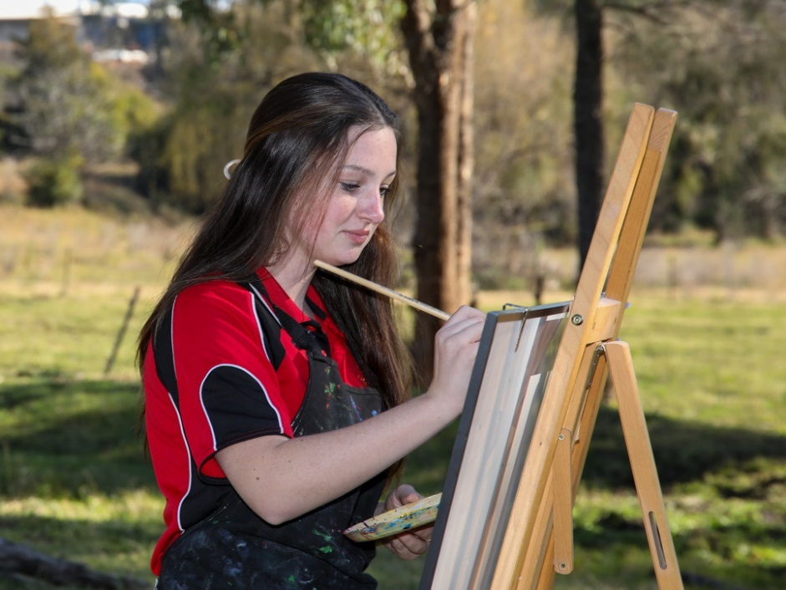
Board Endorsed Courses

Board Endorsed Courses have syllabuses endorsed or approved by the NSW Education Standards Authority (NESA) to cater for areas of special interest. All Board Endorsed Courses count towards the Higher School Certificate and are listed on the Record of School Achievement. However, Board Endorsed Courses do not count towards calculation of the ATAR, as there is no external exam and assessment is school based.

There are several Board Endorsed Courses delivered by the schools and many delivered by TAFE NSW (known as TVET).

EXPLORING EARLY CHILDHOOD NO ATAR
2 Units in Preliminary and/or HSC Board Endorsed Course (School Delivered)

What will I be doing in this course?

Students will learn about issues within an early childhood context. They will follow the development stages of a child from conception through to school age. Students will explore the importance of play, family and community in the socialisation of a child. Apart from the theoretical aspect of each module, students will have the opportunity to partake in practical activities e.g. assisting with childcare.

What should I be able to do at the end of this course?

- Develop an awareness and understanding of the growth, development and learning of young children and the importance of the early childhood years.
- Recognise the uniqueness of all children.
- Become aware of the value of play in the lives of children, including those who have special needs.
- Identify the range of services developed and provided for young children and their families.
- Become aware of the work opportunities in the area of children’s services.

How will this course help me in the future?

Students selecting this course should be interested in gaining a greater understanding of how experiences in childhood years affect a child’s future growth, development and learning. The course would be of benefit to anyone interested in pursuing a career with children. FEES APPLY

MANUFACTURING AND ENGINEERING INTRODUCTION 240 hrs

NO ATAR

2 units in each of Preliminary and/or HSC Board Developed Course
Vocational Education and Training (VET) Course

The Manufacturing and Engineering Introduction curriculum framework includes courses that are accredited for the HSC and provide students with the opportunity to obtain nationally recognised vocational qualifications.

- Students who are assessed as competent in all of the prescribed units of competency in Manufacturing and Engineering Introduction (240 hours) will be eligible for the MEM10119 Certificate I in Engineering and a Statement of Attainment towards the MEM20422 Certificate II in Engineering Pathways.
- Students who are assessed as competent in some units of competency will be eligible for a Statement of Attainment showing partial completion of Certificate I in Engineering or II in Engineering.

What will I be doing in this course?

This course is for students who wish to work in the manufacturing, engineering and related service industries.

The course is based on units of competency developed by the manufacturing, engineering and related service industries to describe the competencies skills and knowledge needed by workers in these industries. The foundation units of competency represent the basic skills, knowledge and attitudes required by all workers within the manufacturing, engineering and related service industries. They specifically address industry awareness, communicating with others, planning for work, quality principles and working safely. These foundation units of competency focus on developing and refining the skills required to work effectively within the industry, and need to be exhibited throughout the entire course.

The competencies from the Fabrication and Machining elective steams complement these competencies by providing a range of practical and technical skills and articulation into the Engineering Fabrication and Metal Machining trades.

What else do I need to know about this course?

- Students must complete a minimum of 35 hours work placement over two years in a metal and engineering workplace.
- This is a competency-based course. This means that students work to develop the competencies, skills and knowledge described in each unit of competency.
- To be assessed as competent a student must demonstrate, to a qualified assessor that they can effectively carry out the various tasks and combinations of tasks listed to the standard required in the industry. There is no mark awarded in competency-based assessment. Students are assessed as either ‘competent’ or ‘not yet competent’. Competency based assessment determines the vocational qualification that a student will receive.
- A materials fee applies to this course.

What should I be able to do at the end of the course?

- Be familiar with the metal and engineering industry and career structures within the industry
- Seek and attain suitable and rewarding employment in the metal and engineering industry
- Function competently and confidently at the entry level standard of an engineering work environment
- Have knowledge and skills required to perform a range of tasks in a variety of industry environments.

How will this course help me in the future?

The competencies, skills and work experience students gain in this course equip them well for direct entry into the work force in areas such as metal fabrication and production as well as many other sections of the metal and engineering industry. This course enhances vocational pathways for students who are interested in pursuing engineering studies in further education. There are direct articulation arrangements with TAFE NSW and students are able to complete a TAFE NSW diploma in minimum time and articulate, if they choose, to university, with significant advanced standing. FEES APPLY

See back of booklet for competency list and further information.

NUMERACY NO ATAR/NO HSC EXAM
2 Units in Preliminary and/or HSC Content Endorsed Course

What will I be doing in this course?

The Numeracy course is designed to offer opportunities for students to reason numerically and think mathematically. Numerical reasoning and mathematical thinking (NRMT) are supported by an atmosphere of questioning, communicating, reasoning and reflecting and are engendered by opportunities to generalise, challenge, find connections and to think critically and creatively.

The course provides opportunities for students to develop 21st-century knowledge, skills, understanding, values and attitudes. As part of this, students are encouraged to learn to use appropriate technology as an effective support for numerical and mathematical activities.

The Numeracy course content comprises 4 modules:
- Module 1 – provides students with the mathematical knowledge, understanding and skills to solve problems relating to operations with whole numbers, distance, area, volume and time. Students are provided with opportunities to extract and interpret information from a variety of simple forms of data representation that are used in everyday contexts.
- Module 2 – provides students with the mathematical knowledge, understanding and skills relating to fractions and decimals, solving problems involving operations with fractions and decimals, metric relationships, length, mass and capacity, and qualitative probability from everyday contexts which are meaningful and of interest.
- Module 3 – provides students with the mathematical knowledge, understanding and skills relating to percentages and their link to fractions and decimals. Students solve problems in context, choosing and using calculation strategies and methods suitable to the context and the degree of difficulty of the calculations involved. Consideration of location, time and temperature, and shape and its relationship to design, are included in this module.
- Module 4 – provides students with the mathematical knowledge, understanding and skills relating to rates and ratios. It further develops the concepts of probability and provides a close link with statistics. Students, with increasing autonomy, solve everyday problems by integrating the NRMT process and the skills and knowledge they have encountered through previous modules.

What should I be able to do at the end of the course?

The study of Numeracy in Stage 6 enables students to build on existing numeracy skills and to develop and improve their capability to:
- interpret and use numerical information
- solve problems using visual, spatial, financial and statistical literacy skills
- think mathematically in practical situations
- represent and communicate information
- use the context to determine the reasonableness of solutions in order to manage situations and solve problems relating to their present and future needs.

How will this course help me in the future?

The Numeracy course supports students to develop the functional numeracy skills required to become active and successful participants in society. Students have the opportunity to develop these skills and apply them to situations in personal and community, workplace and employment, and education and training contexts. This course offers students the opportunity to prepare for post-school options of employment or further training.

PHOTOGRAPHY, VIDEO AND DIGITAL IMAGING NO ATAR
2 Units in Preliminary and/or HSC Board Endorsed Course (School Delivered)

What will I be doing in this course?

Students will learn about basic camera, studio and video techniques. They will also examine special effects and how to manipulate images.

What will I be doing in this course?

- Develop organisational skills and systematic thinking through the acquisition of the techniques of photography.
- Develop an understanding of the methods photographers use to build meanings.
- Increase students visual awareness of their environment and the way photographic representations can be created from this to communicate ideas and feelings.
- Promote an understanding of the wide range of available careers involving photography and of how to go about entering this field.

How will this course help me in the future?

Students selecting this course should be interested in gaining a greater understanding photography. Photography can be used as a basis to provide many skills needed in a variety of creative commercial and artistic fields including, graphic arts, magazine, digital imaging, web design, fashion, film & television, photojournalism and tourism. It provides a useful background for TAFE and university courses in photography, digital imaging, fine arts and visual communications. FEES APPLY

SPORT LIFESTYLE AND RECREATION STUDIES (SLR) NO ATAR
2 Units in Preliminary and/or HSC Board Endorsed Course

What will I be doing in this course?

Students will learn about the importance of a healthy and active lifestyle and recognise the need to be responsible and informed decision makers. This course enables students to further develop their understanding of and competence in a range of sport and recreational pursuits. They are encouraged to establish a lifelong commitment to being physically active and to achieving movement potential.

The course provides the opportunity to specialise in areas of expertise or interest through optional modules such as: Aquatics, Athletics, First Aid, Fitness, Specific Sports, Gymnastics, Outdoor Recreation, Sports Administration, Coaching, Social Perspectives of Sport and Healthy Lifestyle.

What should I be able to do at the end of this course?

- Understand and appreciate the factors that influence health and participation in physical activity.
- Understand the principles that impact on quality of performance.
- Analyse and implement strategies to promote health, activity and enhanced performance.
- Identify the relationship between a healthy lifestyle and diet and exercise.
- Be aware of anatomy and physiology.
- Create and refine their own performance of movement skills and safe sporting practices.

How will this course help me in the future?

Students selecting this course should be interested in sport with a desire to explore the working and functioning of the human body. This course will assist you to make valued and informed health decisions. The course would be of benefit to anyone interested in coaching, sport, the fitness industry, recreational education, physical education and nursing.

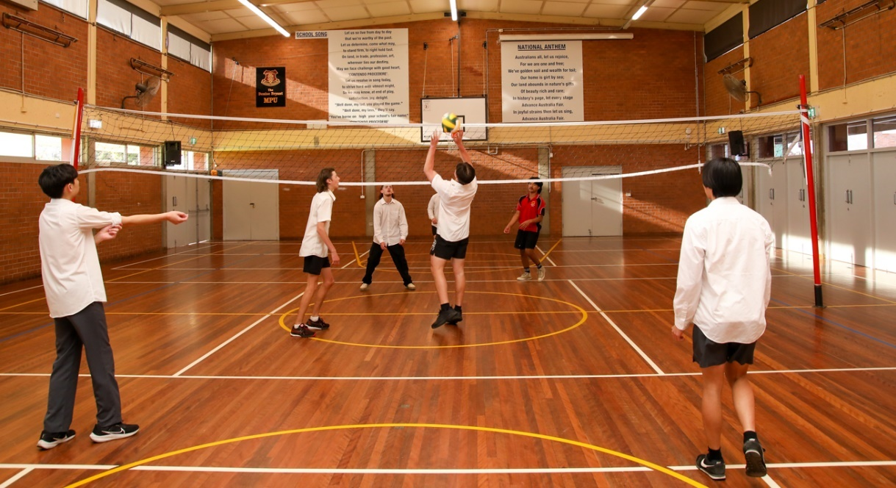

VET AND TVET COURSES

2 Units in Preliminary or HSC
Board Developed & Endorsed Courses TAFE NSW Delivery

The following courses may be available to students for selection next year. Some are eligible for an ATAR rank. #

INVERELL TAFE

- Automotive (Mechanical) #
- Beauty Therapy – Make up Services
- Children’s Services
- Aged Care
- Hairdressing

Other TVET Courses offered through Online/ Distance Education include (Refer to TVET Booklet 2025 for a full list of courses available)

- Accounting #
- Aero Skills
- Animal Care
- Horse Industry Skills
- Tourism & Events #
- Business Services #
- Information and Digital Technology #

VET Courses offered at Inverell High School

RTO descriptions and requirements on the following pages

- Construction #
- Metal & Engineering #
- Primary Industries #

For further information on any of these courses please see Mr Dal Santo and collect an application form.

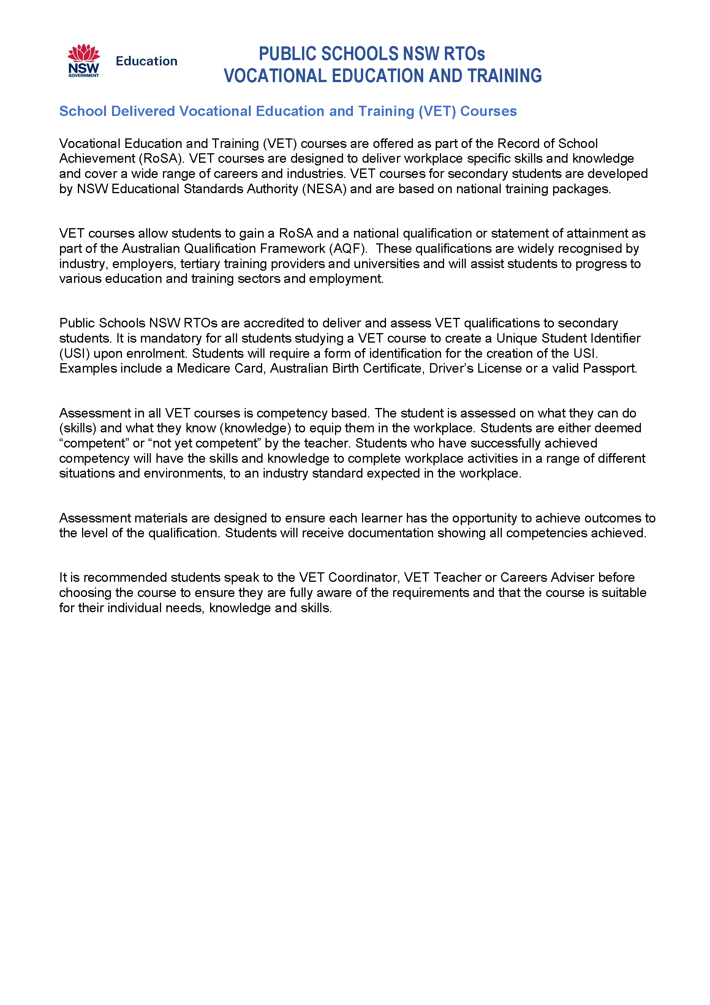
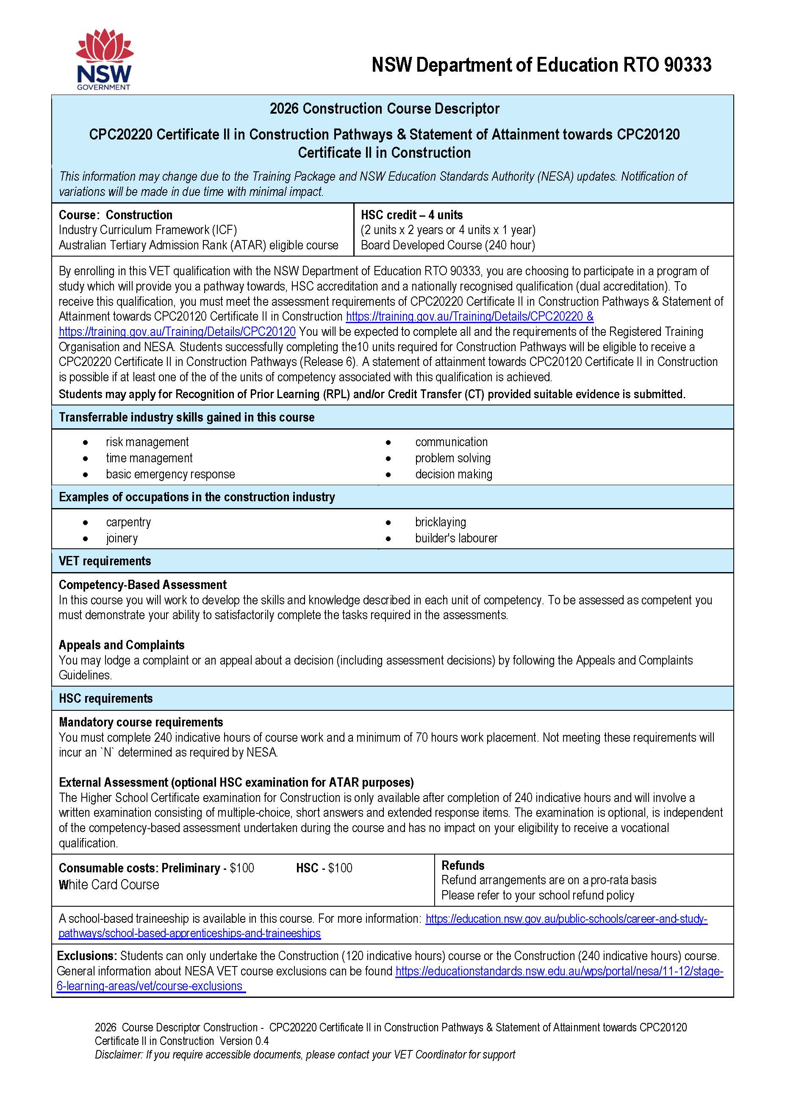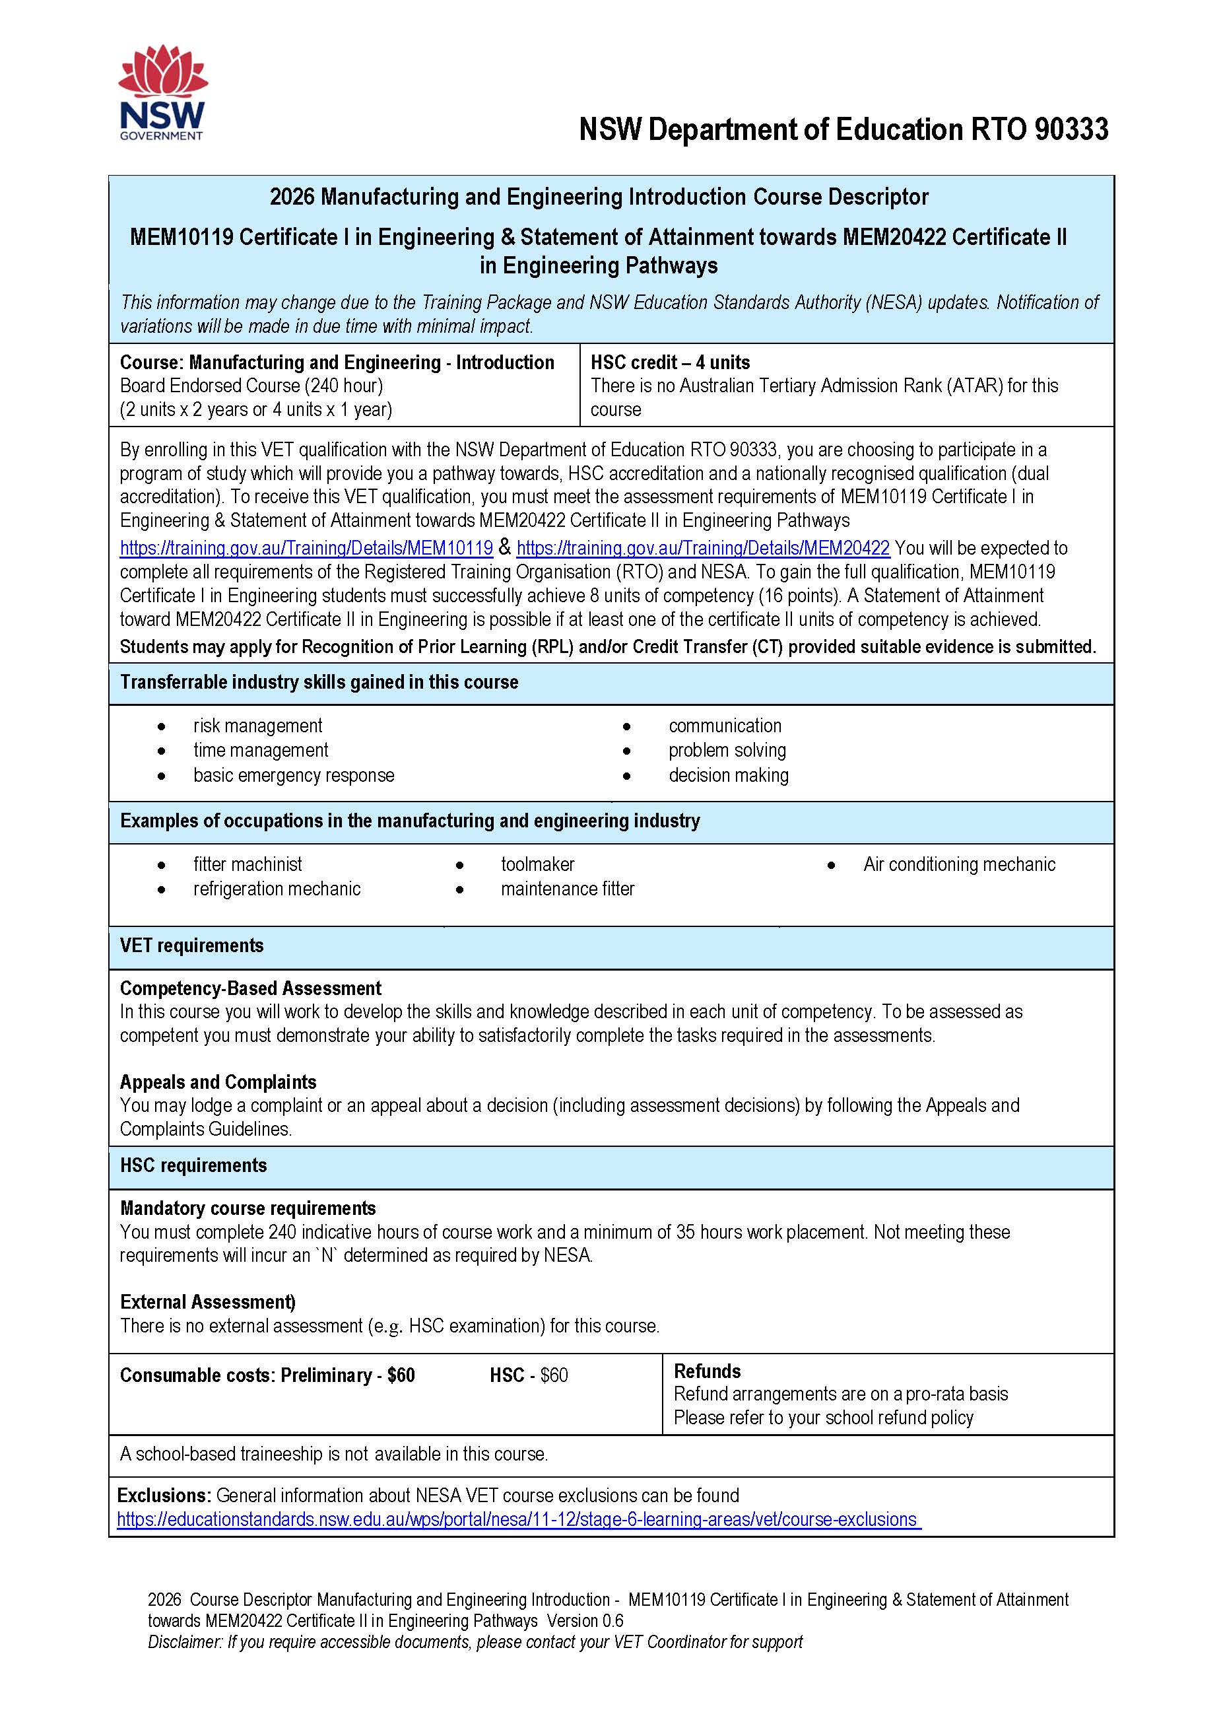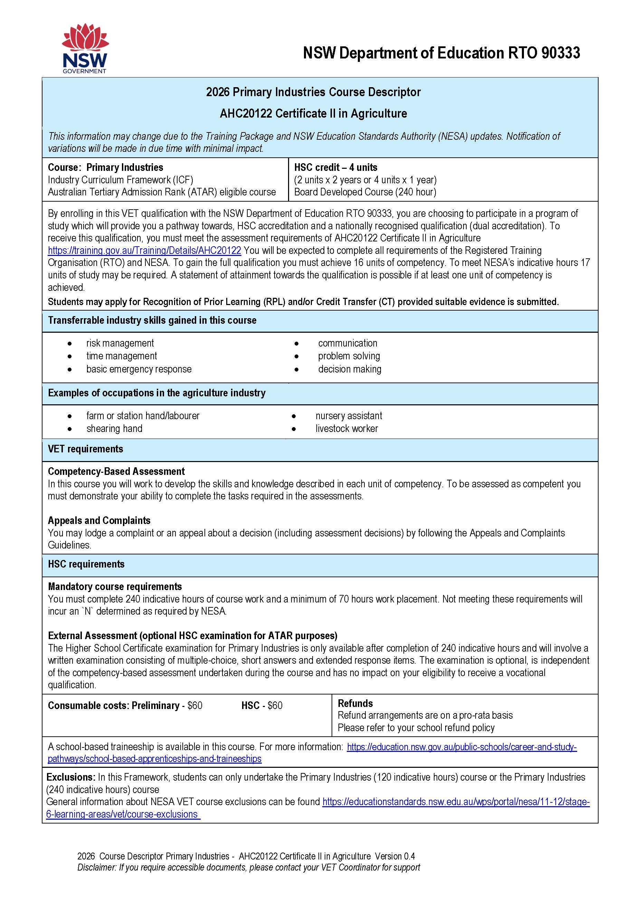

Life Skills HSC

What is a Life Skills course?

Life skills is an alternate and flexible pattern of study. It is a course for students who require a more relevant, accessible and meaningful curriculum option. All students can access Life Skills in subjects apart from Content Endorsed Courses and VET courses.

Life skills students do not have to be assess with assessment tasks.

Students who have been on a Life Skills program prior to Years 11 and 12 are not eligible for ATAR subjects.

The subjects available to students include; English, Mathematics, Science, PDHPE, HSIE, Creative Arts, Citizenship & Society, Technology and Work & the Community, Food Technology, Industrial Technology, Design & Technology, Textiles & Design. Life Skills students are not eligible for extension courses.

Each subject listed above consists of a 2 unit Preliminary and a 2 unit HSC component.

Students may also choose to study a mixed pattern of study, including TAFE or VET options, as well as some Board developed subjects. But this may mean students receive a RoSA as opposed to a Life Skills HSC.

Life Skills subjects DO NOT have HSC examinations.

The Life Skills HSC includes a list of outcomes achieved in that subject rather than a mark.

A decision to go on to a Life Skills program is done in consultation with Learning Support staff, family and student.



Your subject selection for Year 11 2026 and Year 12 2027 will be submitted online through your Edval account. Below is an example of the email you will receive from the school. You will need to choose 6 subject choices (English is first preference compulsory) and 2 reserve subject choices.

Subject Selection information
Dear Student
It is now time for you to enter your subject choices for next year. You will do this online, the details are outlined below.
If you have any questions, please contact Mrs Kearni Reynolds.
Step 1: Log into www.my.edval.education.
Step 2: Enter your personal WebCode to access your subject selection form
(You will receive this in an Email from inverell-h.school@det.nsw.edu.au)
Step 3: Enter the subjects that you want in the order of preference. The subjects that you most want to do should be at the top of your list.
* We will try very hard to grant you your preferred subjects, however, where this is not possible, we will meet with you to discuss your subject selection.
Step 4: Click Submit.
Step 5: Print your submitted form or take a screenshot for future reference.
Online subject selections will open on Monday 4th August, 2025 and close on Friday 15th August, 2025.



INVERELL HIGH SCHOOL

SUBJECT SELECTION INFORMATION

YEAR 11 2026

DETAILS OF ALL COURSES, HSC REQUIREMENTS AND ATAR REQUIREMENTS ARE OUTLINED IN THE BOOKLET
HSC (ATAR) | HSC (no ATAR)
IN 2026 - 2027 TO GAIN AN ATAR YOU NEED:  - at least 2 Units of English  - at least 10 Units of Board Developed Courses  - Minimum 12 Units | IN 2026 - 2027 TO GAIN A HSC YOU NEED:  - Minimum 12 Units Preliminary Courses  - a 2 Unit English Course  - Minimum 6 Units of Board Developed Courses
Yes ◻ No ◻ | Yes ◻ No ◻
You are to choose 6 subjects you wish to study IN ORDER OF PREFERENCE and 2 reserve subjects. While every effort will be made to satisfy your selections, there can be no guarantee that the combination of subjects you have chosen will be available on the final line structure.
Course | Unit |  | Course | Unit
English Standard | 2U |  | Italian (Beginners) - $35 per year | 2U
English Studies | 2U |  | Investigating Science | 2U
English Extension (Preliminary) | 1U |  | Legal Studies | 2U
Aboriginal Studies | 2U |  | Mathematics Advanced | 2U
Agriculture | 2U |  | Mathematics Standard | 2U
Ancient History | 2U |  | Mathematics Extension (Preliminary) | 1U
Biology | 2U |  | Modern History | 2U
Business Studies | 2U |  | Music 1 - $10 per year | 2U
Chemistry | 2U |  | Physics | 2U
Community and Family Studies | 2U |  | Primary Industries - $60 per year | 2U
Construction - $100 per year | 2U |  | Science Extension (HSC) | 1U
Dance | 2U |  | Society & Culture | 2U
Design and Technology - $40 per year | 2U |  | Textiles and Design - $10 per year | 2U
Drama - $20 per year | 2U |  | Visual Arts - $80 per year |  | 2U
Earth and Environmental Science | 2U
Economics | 2U |  | CONTENT ENDORSED COURSES (Non ATAR)
Engineering Studies | 2U |  | Exploring Early Childhood - $20 per year | 2U
Food Technology - $80 per year | 2U |  | Manufacturing and Engineering  Introduction - $60 per year | 2U
Geography | 2U |  | Numeracy | 2U
Health and Movement Science | 2U |  | Photography, Video, Digital Imaging  - $80 per year | 2U
Industrial Technology Automotive - $50 per year | 2U |  | Sport, Lifestyle & Recreation | 2U
Industrial Technology Metals - $80 per year | 2U |  | ALL FEES ARE SUBJECT TO CHANGE

PLEASE NOTIFY MRS REYNOLDS IF YOU WISH TO STUDY A TVET / DISTANCE EDUCATION COURSE
SUBJECT CHOICES WILL CLOSE IN EDVAL ON FRIDAY 15TH AUGUST 2025

