Years 9 & 10 Subject & Elective Choices
2023/2024

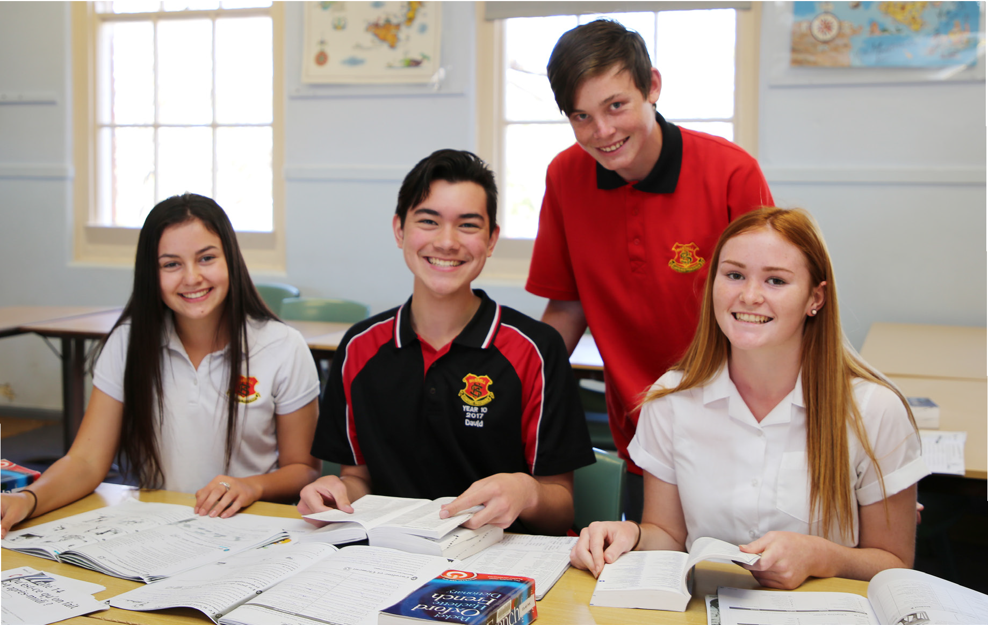

YEARS 9/10 ELECTIVE SUBJECT COURSE DESCRIPTIONS
The following subject outlines may be of assistance to you.

ABORIGINAL STUDIES

Aboriginal Studies is a subject designed for both Aboriginal and non-Aboriginal students. It has the central aim of exploring culture and Aboriginality in a multi-cultural Australia.

The course is divided into several electives, all of which explore Aboriginality. It is a course which crosses over a few different subject areas. Electives include Aboriginal Literature, Languages, Oral History, Community Organisations, Family and Community, Media, Technology and Environment, Sport, Visual and Performing Arts.

Students are given many opportunities to research and work with many community and outside contacts in order to study this course

AGRICULTURE

Agriculture is a subject that offers a combination of theory and practical lessons for students from both rural and non-rural backgrounds. Students will gain knowledge and understanding of agricultural enterprises and the practices and skills required in producing plant and animal products. Students will develop skills in the effective management of sustainable production and marketing practices that are environmentally and socially responsible.

Students will also be involved in the general running of the school agricultural farm and how management decisions are made, as well as also being involved in the preparation of stock for shows. Fees apply.

CHILD STUDIES

Students investigate factors involved in the provision of quality care for young children. The course includes a theoretical component and a range of practical experiences designed to foster student awareness of the complex world of childcare.

Areas of study include preparing for parenthood, conception to birth, family interactions, growth and development, play and the developing child, health and safety in childhood, food and nutrition in childhood, media and technology in childhood and childcare services and career opportunities.

This course will be of interest to students wishing to seek employment in the childcare area and is of general interest to every student as it provides them with knowledge they can apply to their own life. Fees apply.

COMMERCE

Commerce enables young people to develop the knowledge, understanding, skills and values that form the foundation on which they can make informed and responsible decisions about consumer, financial, legal, business, government and employment issues that will affect their everyday lives. Students will study a range of topics ranging from Consumer Choice and Personal Finance through to Legal, Business and Employment issues. The course involves real world experiences such as excursions, visiting speakers and practical experiences which reflect life situations which students may encounter in the future.

DESIGN AND TECHNOLOGY/STEM

In the Year 9-10 Design and Technology course students complete four Design Projects using a variety of materials and tools. In each Design Project students will take part in practical activities in designing, evaluating, using computers, communicating, marketing and managing. The projects will have a STEM (Science Technology, Engineering and Mathematics) focus and could include robotics, 3D Printing and CAD Management. Students will keep a folio of their work and produce a quality product for each unit. Early projects will be negotiated between teacher and students. Later in the course students will have the opportunity to work in an area of personal interest enabling expression of skills and talents. Fees apply.

DRAMA

Drama in Year 9 is designed to introduce you to the world of theatre and develop confidence in performance. It provides you with the opportunity to work both independently and as a group. Drama also allows you to develop your communication, improvisation and self-confidence as you will often perform in front of and with your peers. To succeed in Drama, you should be open to trying new things, working cooperatively with your peers and engaging fully in all aspects of performance. We explore different elements of Drama such as voice and movement and some key forms of Drama including melodrama and mime. Fees apply.

FOOD TECHNOLOGY

Food Technology involves the combination of practical, demonstration and experimental work and related theory topics. Students will be provided with the opportunity to develop knowledge and skills in food preparation and presentation, food processing, putting on events e.g., birthday parties, trends in food styles and dining, menus design, selecting food for healthy lifestyles, food safety and how foods are processed. The course involves equal practical and theory content and both areas are assessed for the RoSA. This course is a good starting platform for employment in the food industry and study in the Hospitality Industry. Fees apply.

FRENCH or ITALIAN

This elective course provides students with the opportunity to gain effective skills in communicating in another language, to explore the relationship between French / Italian and English, and to develop an understanding of that country’s culture. Students will learn to talk about food, travel, sport, hobbies, music, places, family, friends, daily routines and school life. They will listen and respond to spoken language. They will learn to read and respond to written texts and they will establish and maintain communication in familiar situations using French / Italian. Creative use of the language will be encouraged through experiences such as: role-play, singing, language competitions, paired activities, communicative games, films, cuisine lessons, interactive computer software activities and internet research activities.

GRAPHICS TECHNOLOGY

Graphics Technology enables students to engage in both manual and computer-based forms of image generation and develop knowledge of the wide application of graphics in a variety of contexts. Graphics Technology also develops students’ technical and visual literacy, equipping them for participation in a technological world. The course structure builds student’s knowledge and understanding through three core modules and culminates with an elective unit. Fees apply.

HISTORY ELECTIVE

This two-year course is a wonderful opportunity for students to develop skills and knowledge in History and the world we live in today. Elective topics are of high interest and negotiated with students. Topics include: Conspiracy Theories, Crime and Punishment, Heroes and Villains. There are opportunities for students to follow their own interests and present their information in a wide variety of forms.

HORIZONS

Horizons is an elective subject designed to extend Stage 5 High Potential students. The class is based upon a ‘Guided Inquiry’ approach to ‘Learning in the 21st Century’. This is where students find and use a variety of sources of information and theories to develop their understanding of a topic, problem or issue. The topics explored range from several designated research tasks and project-based learning opportunities. Horizons challenges students to explore, research and deliver their findings in a variety of engaging and informative presentation styles. Through this elective students develop sophisticated research skills which can be transferred to other subjects and further developed in their senior years of schooling.

INDUSTRIAL TECHNOLOGY AUTOMOTIVE

This two-year course is one of the most popular in the Industrial Arts faculty. The first three modules concentrate on gaining the skills needed in a mechanics workshop and understanding the theoretical knowledge necessary to work on a variety of two and four stroke engines. Other power sources are investigated. Throughout the course, and especially in the last module, students will be working on engines individually, or in small groups. Student centred projects are encouraged.

All Industrial Technology courses have a balance of 70% practical workshop experiences and 30% theoretical work in the form of class notes, assignments, research and tests. Fees apply.

INDUSTRIAL TECHNOLOGY FARM MAINTENANCE

The Farm Maintenance focus area provides opportunities for students to develop knowledge, understanding and skills in relation to farm maintenance and its associated industries.

The Farm Maintenance 1 course develops knowledge and skills in the use of tools, materials and techniques related to farm maintenance. These are enhanced and further developed through the study of the Farm Maintenance 2 specialist module.

Practical projects reflect the nature of the Farm Maintenance focus area and provide opportunities for students to develop specific knowledge, understanding and skills related to farm maintenance. These may include:

• fences and gates
• maintenance and repair of farm appliances and equipment
• small structures for farm applications
• structures for containing/restraining livestock
• tools and implements to assist on the farm.

This is a practical based course which utilises machinery and tools which require the appropriate footwear and safety clothing associated with a fabrication workshop.

Students will learn a variety of maintenance and problem-solving skills which culminate in the development and production of a major practical project in Year 10. Fees apply.

INDUSTRIAL TECHNOLOGY METAL

The two-year Metal course is taught using the Fitting and Machining and Metal Fabrication modules. The first three modules concentrate on gaining hand skills and competence with the various types of machinery through set projects. The final module works through to the completion of a Major Project. This is always exciting as students can build such items as Bar Stools, Garden Seats, Workshop Benches, Barbeques and Workshop Vices, all displaying the skills acquired over the two years. All students, under the guidance of their teacher, work to their level of ability in this final module leading to a grade in the RoSA. Fees apply.

INDUSTRIAL TECHNOLOGY TIMBER

The two-year timber course is taught using the Cabinetmaking and Wood Machining modules. The first three modules concentrate on gaining hand skills and competence with the various types of machinery through set projects. The final module works through to the completion of a Major Project. This is always exciting as students can build such items as Entertainment Units, Pendulum Clocks, Occasional Tables and Computer Stands, all displaying the skills acquired over the two years. All students, under the guidance of their teacher, work to their level of ability in this final module leading to a grade in the RoSA. Fees apply.

INDUSTRIAL TECHNOLOGY BUILDING & CONSTRUCTION – TRADIE LADIES

This is a recent addition to the school’s Industrial Technology curriculum. The Tradies Ladies Building and Construction course provides opportunities for female students to develop knowledge, understanding and skills in relation to the building and associated industries. The course is designed to develop knowledge and skills in the use of tools, materials and techniques related to the building and construction industry.

Theoretical tasks and practical projects will provide opportunities for students to develop specific knowledge, understanding and skills related to building and construction technologies. These may include the construction of small structures, scale models, elementary repairs and renovations, development of garden and recreational areas.

Practical projects will promote the development of industry related skills through the use a range of tools, equipment and materials used in the Construction Industry. Associated theory will enhance student knowledge and understanding of WH&S, Design, Material types, Workplace Communication, Societal and Environmental Impact, Career Paths within the Construction Industry. Fees apply.

MUSIC

Did you enjoy Music in Year 7 and Year 8? Can you remember a little something about reading and playing chords? Would you like to get more experience on an instrument? Would you like to perform with a group of similarly interested and talented students? Elective Music might be for you.

Music in Years 9 and 10 allows opportunities for composing, performing and listening to music from a range of eras and styles. There are two groups of topics that can be chosen is a course with many possibilities. It allows students to explore music through performance, composition, listening and historical impacts. The mandatory course requires students to study a broad range of contexts including art music. The elective course requires students to study one compulsory topic- Australian Music as well as a number of other topics from two defined groups that aim to provide depth and breadth of musical study. Students are expected to develop solo and group performance pieces, compose on music software and analysis music under the six concepts of music.

Course assessment is based on 25% Performance, 25% Aural studied, 25% historical studies and 25% Composition. Fees apply.

PHOTOGRAPHIC AND DIGITAL MEDIA

The Photographic and Digital Media course is a subject that encourages students to develop skills, techniques, processes and ideas in established and new technologies. The emphasis is on individual creative and practical work. Students will be exposed to various forms of computer-generated art (digital art), video and photography. Students will learn how to work with cameras and manipulate images on the computer.

Students are required to keep a journal in this course. The Photographic and Digital Media journal can include evidence of research and investigation which may include some of the ideas, interests and concepts that students explore, and their experiments with media, techniques and processes. This evidence may be in the form of drawing, photographic and digital document, collections, sketches, notes, annotated diagrams, critical and reflection. Fees apply. Students will have the opportunity to create:

- Horror Films
- Music Videos
- Photomontages
- Photograph Contemporary Life
- Digital Manipulations

PHYSICAL ACTIVITY AND SPORTS STUDIES

This is a highly practical subject where students learn through movement and put their understandings into practice in a range of selected movement contexts. Students will have the opportunity to participate in recreational activities to develop lifelong skills. Students also have the opportunity to explore issues relating to sport and physical activity such as nutrition, improved performance, coaching and sport & society.

Throughout the course, students will develop skills that enhance their participation in and enjoyment of physical activity.

TEXTILES TECHNOLOGY

This course involves a combination of practical and theory work. Students will have the opportunity to develop construction skills utilising fabric, yarns and fibres to create textile products. Areas of construction include soft furnishings, fashion wear, sleepwear, non- apparel, costumes and textile arts. Students will learn about fibres, yarns and fabrics and new technological advances in textiles e.g., e-textiles. Students will also gain skills in fabric decoration such as dyeing, applique, printing, machine embroidery, marbling and silk painting. Fees apply.

VISUAL ARTS

Years 9/10 Visual Art involves the exploration of art and artmaking processes. Students learn correct techniques in areas such as printing, ceramics, painting and sculpture. Theory is self-directed and involves investigating artists and their art making practices. Each student will acquire a range of skills and discover themselves as individuals rather than just another student within a class. The course fee covers the cost of materials and the Visual Arts Process Diary. The course requires 70% practical participation and 30% theory. Much of the practical requires the students to initiate their own art making. Fees apply.

70-92 Brae Street, Inverell NSW 2360
Ph: 02 6722 3777 Fax: 02 6722 5829

e: inverell-h.school@det.nsw.edu.au
w: www.inverell-h.schools.nsw.edu.au

ELECTIVE CHOICES - YEAR 9 2023 (and YEAR 10 2024)

This year your elective preferences for 2023 will be submitted online through your Edval account (like how you have been making your sports choices each term). Below is an example of the email you will receive from the school. You will need to choose 3 first elective choices and 2 reserve elective choices.

Subject Selection information
Dear Student
It is now time for you to enter your subject choices for next year. You will do this online, the details are outlined below.
If you have any questions, please contact Mr Peter Dal Santo.
Step 1: Log into www.my.edval.education.
Step 2: Enter your personal WebCode to access your subject selection form
(You will receive this in an Email from inverell-h.school@det.nsw.edu.au)
Step 3: Enter the subjects that you want in the order of preference. The subjects that you most want to do should be at the top of your list.
* We will try very hard to grant you your preferred subjects, however, where this is not possible, we will meet with you to discuss your subject selection.
Step 4: Click Submit.
Step 5: Print your submitted form or take a screenshot for future reference.
Online subject selections will open on Monday 8th August, 2022 and close on Monday 15th August, 2022.

