Years 9 & 10 Subject & Elective Choices
2026/2027

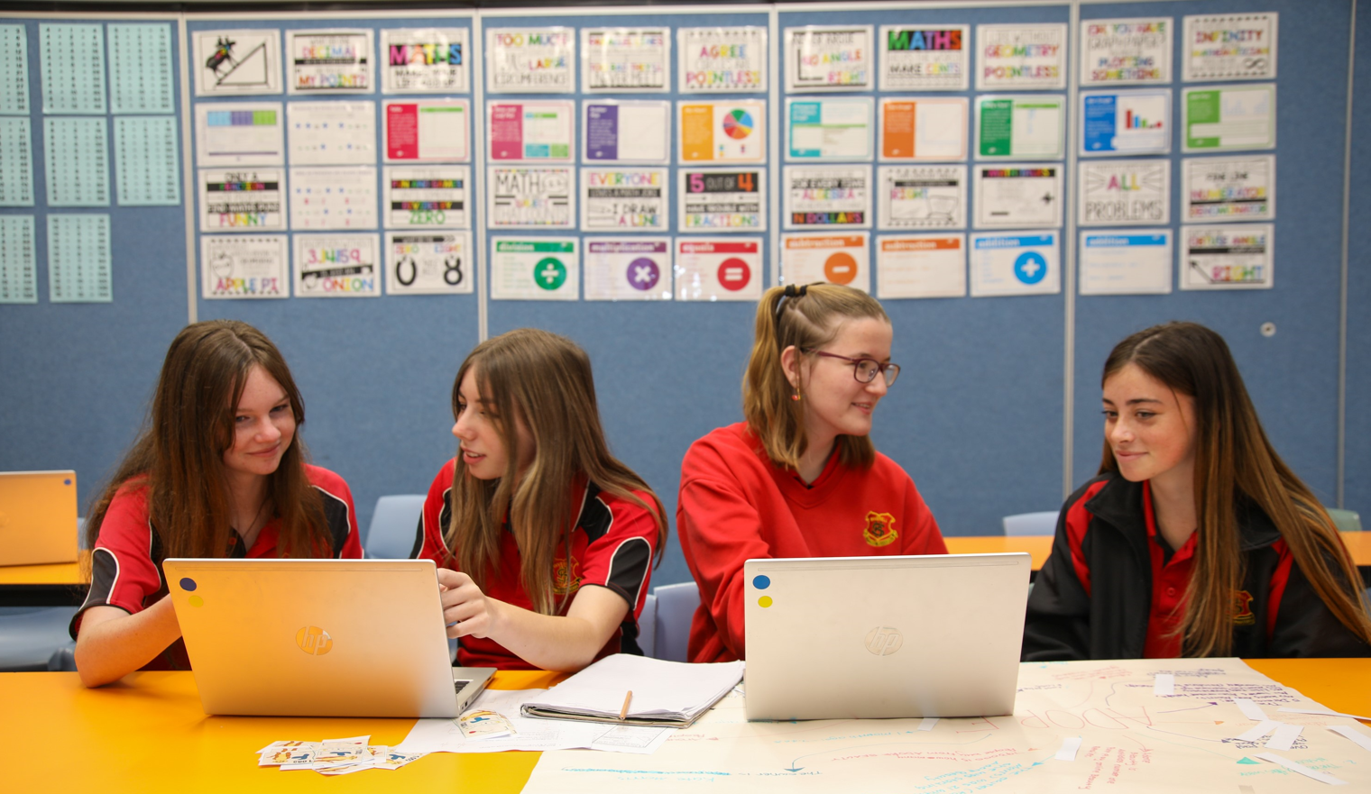

YEARS 9/10 ELECTIVE SUBJECT COURSE DESCRIPTIONS
The following subject outlines may be of assistance to you.

ABORIGINAL STUDIES

Aboriginal Studies is a subject designed for both Aboriginal and non-Aboriginal students. It has the central aim of exploring culture and Aboriginality in a multi-cultural Australia.

The course is divided into several electives, all of which explore Aboriginality. It is a course which crosses over a few different subject areas. Electives include Aboriginal Literature, Languages, Oral History, Community Organisations, Family and Community, Media, Technology and Environment, Sport, Visual and Performing Arts.

Students are given many opportunities to research and work with many community and outside contacts in order to study this course
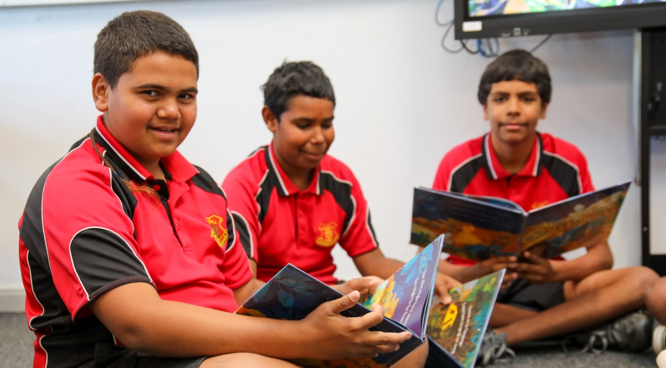

AGRICULTURE

Agriculture is a subject that offers a combination of theory and practical lessons for students from both rural and non-rural backgrounds. Students will gain knowledge and understanding of agricultural enterprises and the practices and skills required in producing plant and animal products. Students will develop skills in the effective management of sustainable production and marketing practices that are environmentally and socially responsible.

Students will also be involved in the general running of the school agricultural farm and how management decisions are made, as well as also being involved in the preparation of stock for shows. Fees apply.
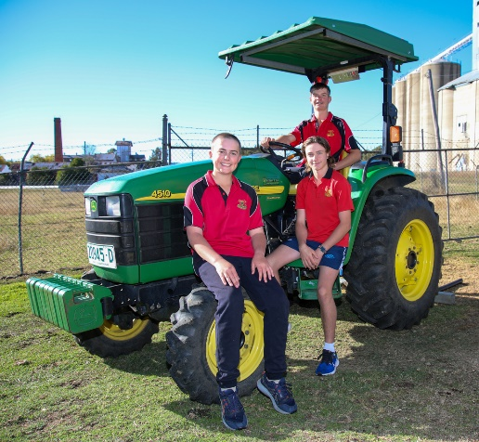
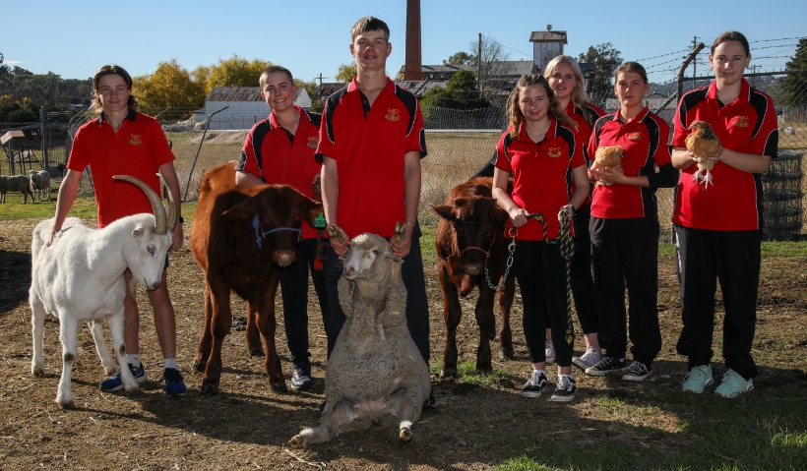

CHILD STUDIES

Students investigate factors involved in the provision of quality care for young children. The course includes a theoretical component and a range of practical experiences designed to foster student awareness of the complex world of childcare.

Areas of study include preparing for parenthood, conception to birth, family interactions, growth and development, play and the developing child, health and safety in childhood, food and nutrition in childhood, media and technology in childhood and childcare services and career opportunities.

This course will be of interest to students wishing to seek employment in the childcare area and is of general interest to every student as it provides them with knowledge they can apply to their own life. Fees apply.

COMMERCE

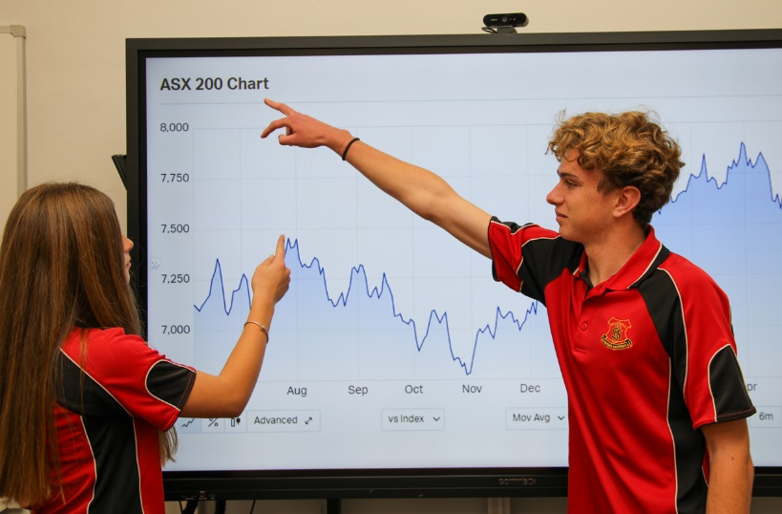
Commerce enables young people to develop the knowledge, understanding, skills and values that form the foundation on which they can make informed and responsible decisions about consumer, financial, legal, business, government and employment issues that will affect their everyday lives. Students will study a range of topics ranging from Consumer Choice and Personal Finance through to Legal, Business and Employment issues. The course involves real world experiences such as excursions, visiting speakers and practical experiences which reflect life situations which students may encounter in the future.

DANCE
Do you have an interest in dance and wanting to learn what it’s like to be performer? Or maybe you already have dance training and wanting to continuously build on your skills? No matter what stage you’re at by choosing Dance as an elective, students will have the opportunity to explore themselves and the world that surrounds them through an artistic lens of movement and expression. The course contains both theory and practical lessons and focuses on 3 components being:
- Performance and what it entitles being the performer.
- Composition and the process on creating movement and performance pieces.
- Appreciation from the viewer/ audience perspective.
Throughout the subject students will also have opportunities for exploring offsite facilities to allow for authentic experiences within the art of dance. Stage 5 dance is also a gateway and provides insight into the requirements of student expectations for the Stage 6 HSC subject.

DESIGN AND TECHNOLOGY - STEM

In the Year 9-10 Design and Technology - STEM course students complete four Design Projects using a variety of materials and tools. In each Design Project students will take part in practical activities in designing, evaluating, using computers, communicating, marketing and managing. The projects will have a STEM (Science Technology, Engineering and Mathematics) focus and could include robotics, 3D Printing and CAD Management. Students will keep a folio of their work and produce a quality product for each unit. Early projects will be negotiated between teacher and students. Later in the course students will have the opportunity to work in an area of personal interest enabling expression of skills and talents. Fees apply.
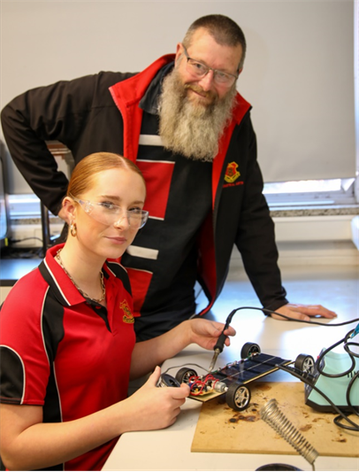
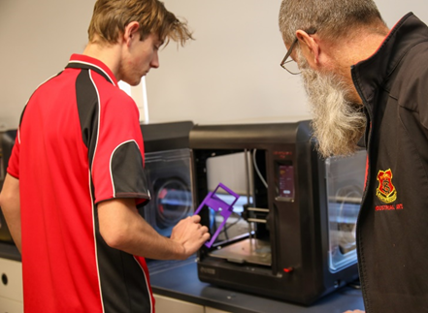

DRAMA

Drama in Year 9 is designed to introduce you to the world of theatre and develop confidence in performance. It provides you with the opportunity to work both independently and as a group. Drama also allows you to develop your communication, improvisation and self-confidence as you will often perform in front of and with your peers. To succeed in Drama, you should be open to trying new things, working cooperatively with your peers and engaging fully in all aspects of performance. We explore different elements of Drama such as voice and movement and some key forms of Drama including melodrama and mime. Fees apply.

FOOD TECHNOLOGY

Food Technology involves the combination of practical, demonstration and experimental work and related theory topics. Students will be provided with the opportunity to develop knowledge and skills in food preparation and presentation, food processing, putting on events e.g., birthday parties, trends in food styles and dining, menus design, selecting food for healthy lifestyles, food safety and how foods are processed. The course involves equal practical and theory content and both areas are assessed for the RoSA. This course is a good starting platform for employment in the food industry and study in the Hospitality Industry. Fees apply.

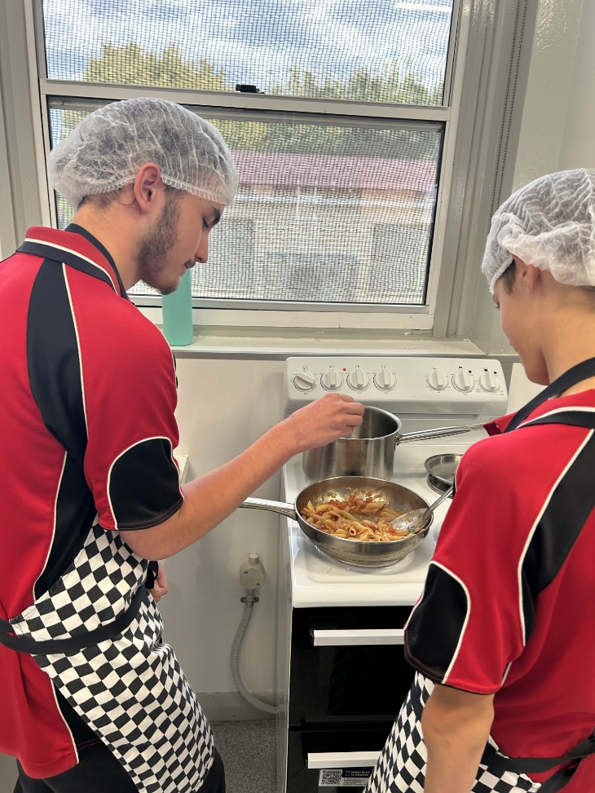
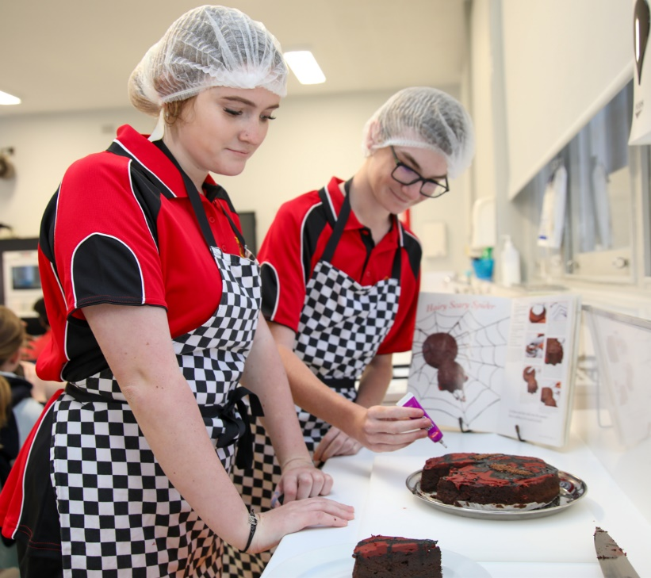

FRENCH or ITALIAN

This elective course provides students with the opportunity to gain effective skills in communicating in another language, to explore the relationship between French / Italian and English, and to develop an understanding of that country’s culture. Students will learn to talk about food, travel, sport, hobbies, music, places, family, friends, daily routines and school life. They will listen and respond to spoken language. They will learn to read and respond to written texts and they will establish and maintain communication in familiar situations using French / Italian. Creative use of the language will be encouraged through experiences such as: role-play, singing, language competitions, paired activities, communicative games, films, cuisine lessons, interactive computer software activities and internet research activities.
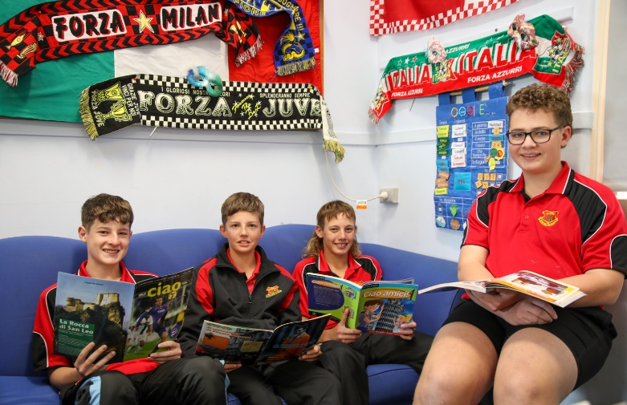
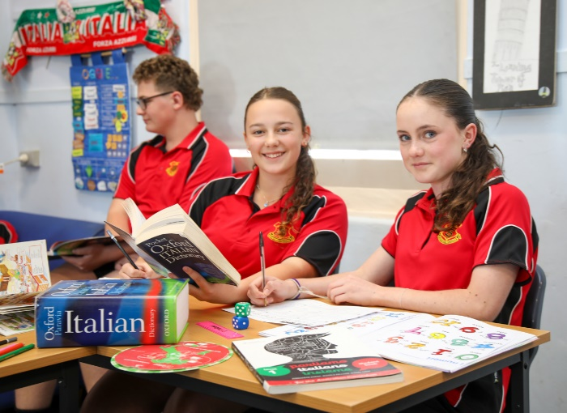

HISTORY ELECTIVE

This two-year course is a wonderful opportunity for students to develop skills and knowledge in History and the world we live in today. Elective topics are of high interest and negotiated with students. Topics include: Conspiracy Theories, Crime and Punishment, Heroes and Villains. There are opportunities for students to follow their own interests and present their information in a wide variety of forms.
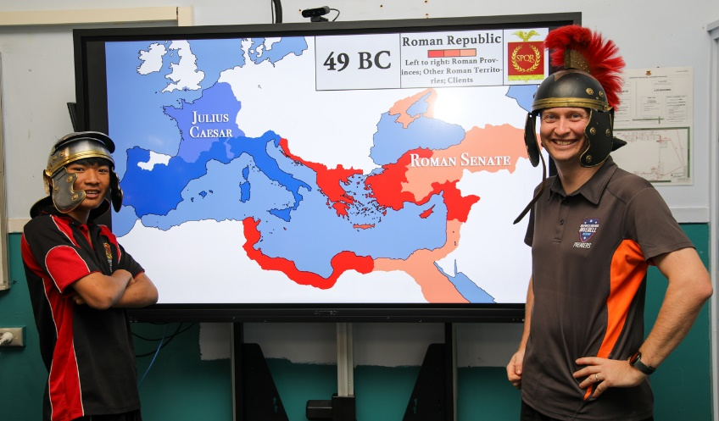

INDUSTRIAL TECHNOLOGY AUTOMOTIVE

This two-year course is one of the most popular in the Industrial Arts faculty. The first three modules concentrate on gaining the skills needed in a mechanics workshop and understanding the theoretical knowledge necessary to work on a variety of two and four stroke engines. Other power sources are investigated. Throughout the course, and especially in the last module, students will be working on engines individually, or in small groups. Student centred projects are encouraged.

All Industrial Technology courses have a balance of 70% practical workshop experiences and 30% theoretical work in the form of class notes, assignments, research and tests. Fees apply.

INDUSTRIAL TECHNOLOGY METAL

The two-year Metal course is taught using the Fitting and Machining and Metal Fabrication modules. The first three modules concentrate on gaining hand skills and competence with the various types of machinery through set projects. The final module works through to the completion of a Major Project. This is always exciting as students can build such items as Bar Stools, Garden Seats, Workshop Benches, Barbeques and Workshop Vices, all displaying the skills acquired over the two years. All students, under the guidance of their teacher, work to their level of ability in this final module leading to a grade in the RoSA. Fees apply.
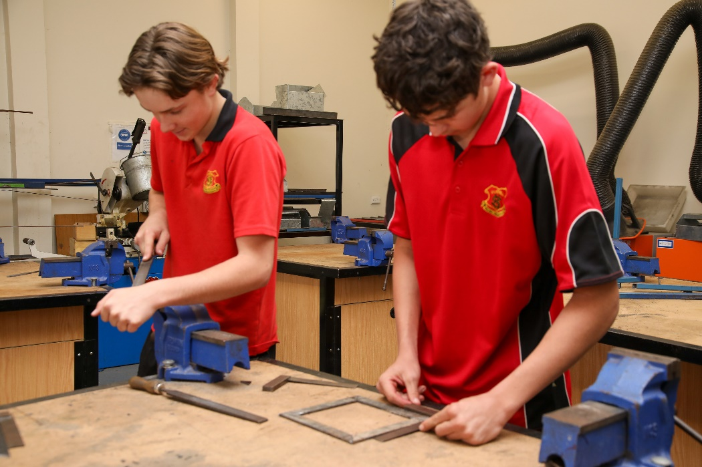

INDUSTRIAL TECHNOLOGY TIMBER

The two-year timber course is taught using the Cabinetmaking and Wood Machining modules. The first three modules concentrate on gaining hand skills and competence with the various types of machinery through set projects. The final module works through to the completion of a Major Project. This is always exciting as students can build such items as Entertainment Units, Pendulum Clocks, Occasional Tables and Computer Stands, all displaying the skills acquired over the two years. All students, under the guidance of their teacher, work to their level of ability in this final module leading to a grade in the RoSA. Fees apply.

MUSIC
Did you enjoy Music in Year 7 and Year 8? Can you remember a little something about reading and playing chords? Would you like to get more experience on an instrument? Would you like to perform with a group of similarly interested and talented students? Elective Music might be for you.
Music in Years 9 and 10 allows students to explore music through performing, listening and composing, ensuring engagement with a range of music that reflects its significance across stylistic, cultural, historical and social contexts. The elective course is organised into three content groups: Music in Practice, Music in Context and Elements of Music.
Students will undertake a depth study, drawing on content studied in class, and applying knowledge, understanding and skills in an area of individual interest. Depth studies may be completed individually or collaboratively. Students may choose to specialise in one or more of the focus areas: Performing, Listening and Composing.
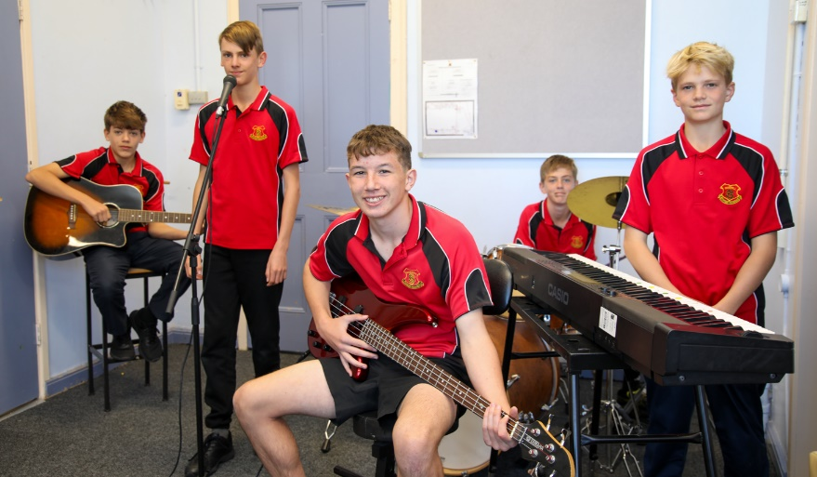
Music fosters an understanding of continuity and change, connecting cultures, times and regions. The transferable skills developed through the study of Music support students to follow a broad range of pathways and professions.
Fees apply.

PHOTOGRAPHIC AND DIGITAL MEDIA

The Photographic and Digital Media course is a subject that encourages students to develop skills, techniques, processes and ideas in established and new technologies. The emphasis is on individual creative and practical work. Students will be exposed to various forms of computer-generated art (digital art), video and photography. Students will learn how to work with cameras and manipulate images on the computer.

Students are required to keep a diary in this course. The Photographic and Digital Media journal can include evidence of research and investigation which may include some of the ideas, interests and concepts that students explore, and their experiments with media, techniques and processes. This evidence may be in the form of drawing, photographic and digital document, collections, sketches, notes, annotated diagrams, critical and reflection. Fees apply.

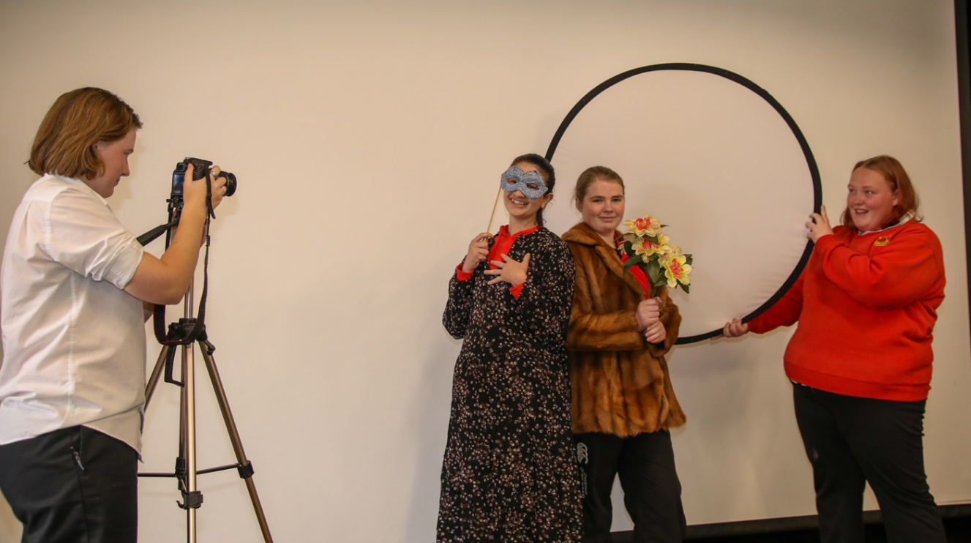

PHYSICAL ACTIVITY AND SPORTS STUDIES

This is a highly practical subject where students learn through movement and put their understandings into practice in a range of selected movement contexts. Students will have the opportunity to participate in recreational activities to develop lifelong skills. Students also have the opportunity to explore issues relating to sport and physical activity such as nutrition, improved performance, coaching and sport & society.

Throughout the course, students will develop skills that enhance their participation in and enjoyment of physical activity.

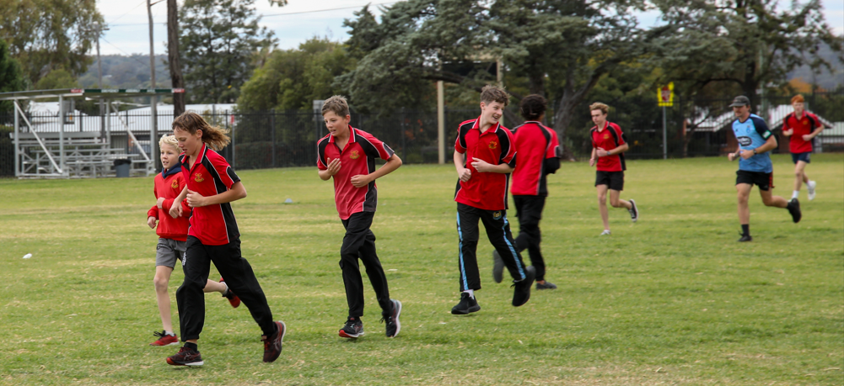

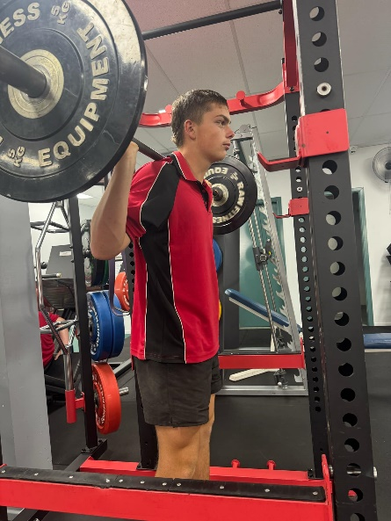
TALENTED SPORTS PROGRAM (TSP)

The Talented Sporting Program (TSP) is an opportunity for driven, sport-loving students to take their skills to the next level. With access to local training facilities like the gym and poll, and the potential chance to attend excursions to UNE, TSP is the perfect pathway to athletic excellence.

Content for the TSP includes – fitness testing, sports nutrition, movement science, resistance training, sport psychology and skill acquisition, athlete management, sports injuries and training methods.

TEXTILES TECHNOLOGY

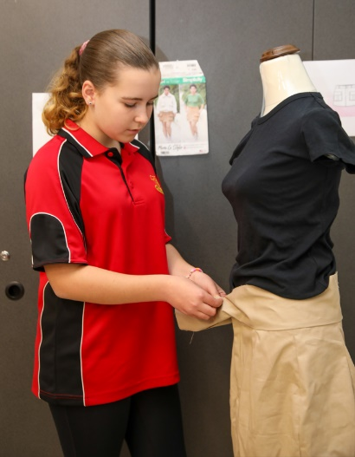
This course involves a combination of practical and theory work. Students will have the opportunity to develop construction skills utilising fabric, yarns and fibres to create textile products. Areas of construction include soft furnishings, fashion wear, sleepwear, non- apparel, costumes and textile arts. Students will learn about fibres, yarns and fabrics and new technological advances in textiles e.g., e-textiles. Students will also gain skills in fabric decoration such as dyeing, applique, printing, machine embroidery, marbling and silk painting. Fees apply.

VISUAL ARTS

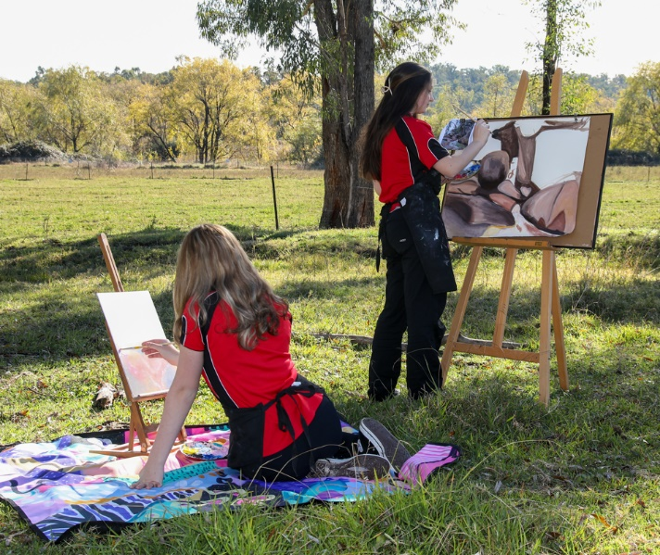
Years 9/10 Visual Art involves the exploration of art and artmaking processes. Students learn correct techniques in areas such as printing, ceramics, painting and sculpture. Theory is self-directed and involves investigating artists and their art making practices. Each student will acquire a range of skills and discover themselves as individuals rather than just another student within a class. The course fee covers the cost of materials. Students are required to purchase their own Visual Arts Process Diary. The course requires 70% practical participation and 30% theory. Much of the practical requires the students to initiate their own art making. Fees apply.

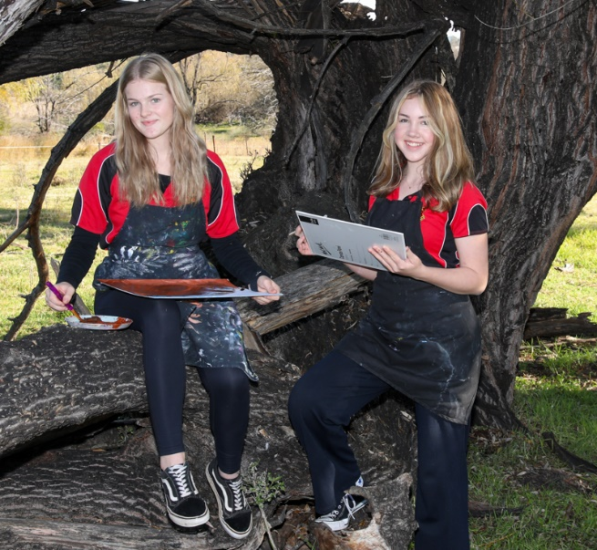

STAGE 5 MATHEMATICS

The new Mathematics syllabus implements a Core–Paths structure, designed to extend students as far along the continuum of learning as possible and provide solid foundations for the highest levels of student achievement.

The Core outcomes provide students with the foundation for Mathematics in Stage 6. The Path outcomes are used to prepare students with the knowledge and skills necessary to engage in the highest level of mathematics possible.

The aim is for most students to demonstrate achievement of the Core and as many Path outcomes as achievable by the end of Stage 5.

Advanced Pathway
Students in this pathway will progress rapidly through the Core topics so that they will have time to more fully cover as many Path topics as possible. This means they will be prepared for Year 11 Mathematics Advanced and Mathematics Extension 1. This pathway is suited for students who consistently achieved excellent results in Stage 4 Mathematics and possess a strong work ethic.

Standard Pathway
Students will cover every Core topic and a variety of Path topics for Mathematics Standard and Mathematics Advanced. Students on this pathway will be well prepared for Year 11 Mathematics Standard and Year 12 Mathematics Standard 2. This pathway is suited for students who consistently achieved sound results in Stage 4.

Core Pathway
Students will study the Core topics with extensive consolidation of prior learning from Stage 4. As many of the Path topics for Mathematics Standard as possible will also be covered. Students who require ongoing support in completing all Stage 5 Core outcomes may consider either Mathematics Standard 1 or the Numeracy CEC course in Stage 6.





70-92 Brae Street, Inverell NSW 2360
Ph: 02 6722 3777 Fax: 02 6722 5829

e: inverell-h.school@det.nsw.edu.au
w: www.inverell-h.schools.nsw.edu.au

ELECTIVE CHOICES - YEAR 9 2026 (and YEAR 10 2027)

This year your elective preferences for 2025 will be submitted online through your Edval account (same as how you have been making your sports choices each term). Below is an example of the email you will receive from the school. You will need to choose 3 first elective choices and 2 reserve elective choices.

Subject Selection information
Dear Student
It is now time for you to enter your subject choices for next year. You will do this online, the details are outlined below.
If you have any questions, please contact Mrs Kearni Reynolds.
Step 1: Log into www.my.edval.education.
Step 2: Enter your personal WebCode to access your subject selection form
(You will receive this in an Email from inverell-h.school@det.nsw.edu.au)
Step 3: Enter the subjects that you want in the order of preference. The subjects that you most want to do should be at the top of your list.
* We will try very hard to grant you your preferred subjects, however, where this is not possible, we will meet with you to discuss your subject selection.
Step 4: Click Submit.
Step 5: Print your submitted form or take a screenshot for future reference.
Online subject selections will open on Monday 4th August, 2025 and close on Friday 15th August, 2025.

